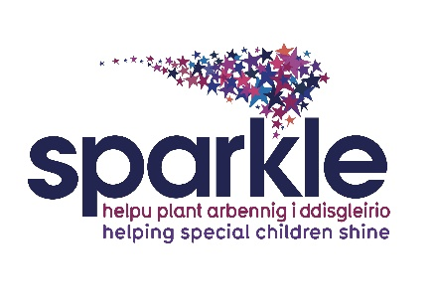

Sparkle Aquatic Helper

Job Description

Post title: Sparkle Aquatic Helper

Responsible to: Activities Development Officer

Location: Crownbridge school Cwmbran

Rate of pay: National minimum wage – age dependent

Hours: Monday 1.5 hours

Contract Period: 12 months fixed term contract

Job Purpose
To offer assistance to children/young people with disabilities and/or developmental difficulties from within the swimming pool, under the supervision of a swimming teacher. The role may also entail offering support to the swimming teacher in a poolside capacity, by observing the children/young people within the lesson, and also assisting with administration duties.

The role of the Aquatic Helper
- To be a role model
- Assist children and young people in the water that need support, by encouraging them, offering manual support and reassurance.
- Ensure equipment is set up ready for the start of the lesson.
- Assist the swimming teacher in delivering fun, challenging, enjoyable lessons.
- Assist in checking of teaching equipment, ensuring it is fit for purpose. Report any defects in apparatus and equipment to Sparkle Lifeguards or Sparkle Team Leader.

- Treat all children and young people fairly and consistently.
- Ensure professionalism at all times.
- Participate in all necessary external and internal training as required by Sparkle or Aneurin Bevan University Health Board and comply with the requirements of ongoing training in line with your qualification.
- Assist in the promotion of the facility by maintaining a high standard of dress and appearance at all times.
- To volunteer your time on up to 4 days per annum (pro rata) for the purposes of running or assisting in Sparkle Fun Days or similar.

- Undertake any other duties, commensurate with the grade of the post, as directed by the Sparkle Leisure Team Leader.
Management Responsibilities
No management responsibilities

Responsible to
Activities Development Officer

Pre-employment recruitment

Prior to employment commencing all staff are subject to an occupational health assessment and Enhanced Disclosure and Barring check with a children barred list check. Once these checks are completed employment can commence. We are a small charity and recruitment costs are high and therefore if a candidate decides to withdraw before commencement or within induction period Sparkle will seek to recover these costs from the candidate.

Disclosure and Barring Service
This post is subject to an enhanced Disclosure and Barring check with a children barred list check.

This post is subject to an exception order under the provisions of the Rehabilitation of Offenders Act 1974. This stipulates that all previous convictions, including those that are ‘spent’ must be declared.

Previous convictions will not necessarily preclude an individual from employment but must be declared in writing at the appropriate stage during the recruitment process.

Person Specification
 | Essential | Desirable | Indicated by
Experience |  | Experience of working in a leisure facility  Working with Children and Young People with a disability or developmental difficulty and their families | Application Form & Interviews
Knowledge | Knowledge of swimming and swimming techniques that are taught to help participants |  | Application Form & Interviews
Professional Skills | Ability to interact with children & young people  Establish good working relationships with staff and volunteers  Are able to adapt quickly and flexibly to situations to ensure the smooth running of sessions should unexpected events occur  Are polite and courteous at all times, regardless of the situation |  | Application Form, Interviews & references
Personal  Attributes | Motivated  Adopt a friendly, happy, welcoming approach  Approachable  Excellent communication skills  Reliable and committed  Organised  Able to work as part of a team  Show empathy, patience and understanding |  | Application Form, Interviews & references

