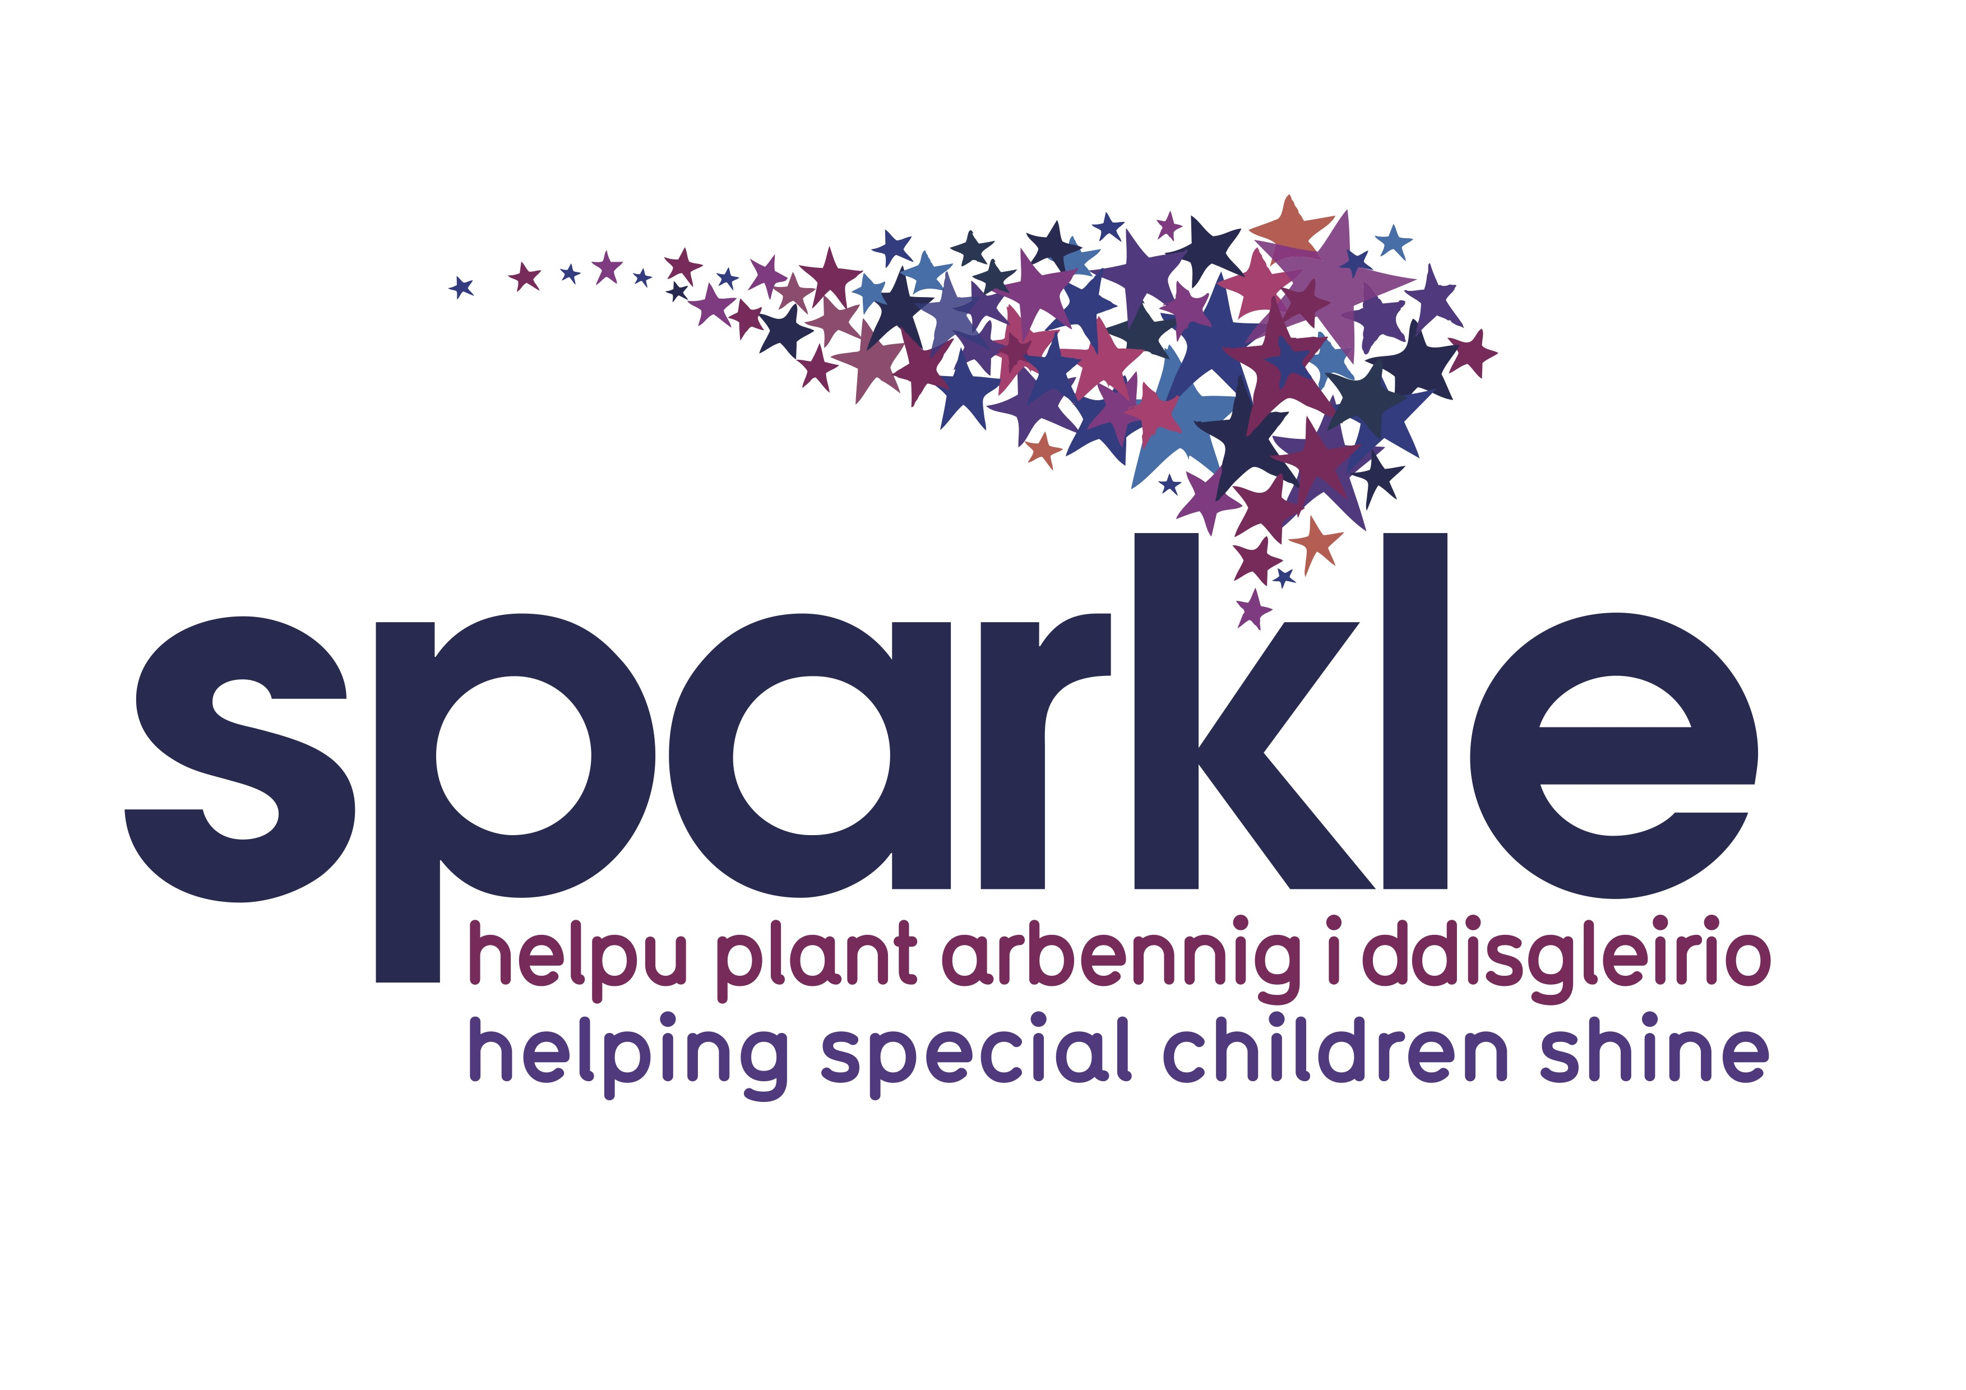
Help us Make Special Children Shine
We are recruiting a Trustee to join our Board of Trustees

What do we do…
Sparkle is a charity based in South Wales, providing a range of support and activities for children with disability or learning difficulties, aged 0-18 years. We believe that all children and young people with complex additional needs should be able to achieve their full potential, regardless of their disability or learning difficulties. In order to achieve this, we have built an award winning fully integrated Children’s Centre in South Gwent, Serennu, encompassing state of the art equipment and leisure facilities, where health and social care staff operate side by side with the Sparkle team. This Centre serves families in Newport, South Torfaen and South Monmouthshire.
Our team provide family support, leisure clubs and activities including swimming, a 3D Cinema experience, and residential outward bound trips for children and young people (CYP) aged 0-18 years. Please take a look at our website, sparkleappeal.org, to see how far we have come since opening in 2011.
Our current expenditure is £630k annually, which we raise from grants, corporate donations, and community based activities.
We have also led the way in developing new service models for our families, and work in close partnership with Health and Social Care providers across the region to deliver these new ways of working. This work is attracting interest from around the UK, as all of our service models have arisen from issues identified by parents and children/ young people themselves.
We are now at an exciting stage, as we have expanded to become the partner charity across the whole of Gwent, and we are now striving to ensure that the families across our region can access similar high quality provision. We are also working to provide resources for the five Local Authorities that we serve, eg a Transition Hub to support young people moving into adulthood.
Who are we looking for and why?
The Trustee Board already has a diverse mix of backgrounds and experience. Together, we have detailed our Charity’s strategy and vision for the next five years and have identified some areas we would like to strengthen in order to achieve our goals.
Sparkle has a clear strategy in place, a solid financial base and a well-led senior management team, we are looking for someone who is passionate and supportive about Sparkle’s work, even if they do not have prior experience of working with disability or learning difficulties.
We would love to speak to candidates with specialist skills in any of the following sectors:

- Marketing skills and knowledge
- PR and Stakeholder Relations – knowledge that supports promoting a positive perspective about the charity/ advising on building relationships with press contacts/stakeholder communication and relationship development
- Knowledge of CMS platforms
- Digital/Social Media communications and analytics experience across various platforms in a business capacity
- Skills to raise the charity’s profile encouraging new supporters, donors and beneficiaries

This position would suit someone either taking their first steps to develop wider board level and governance experience, or with prior experience.
The role and your commitment
The Trustee Board meets monthly (currently remote) for approximately 2 hours. In addition there are some ad hoc meetings depending upon the needs of the charity, and the additional guidance you would be giving to our team members.
The charity has an office based team which includes a Team Lead, Corporate Fundraiser and Digital Communications Officer, there would be an expectation to mentor and oversee activities in this area as and when necessary. We also employ a research & development officer who prepares grant submissions up to 50K, and we contract a professional grant writer for grants above this level.
It is estimated that total time commitment would be no more than two days a month. It is not essential that you live locally but we would expect you to attend the centre occasionally for specific events.
Your Rewards
This work would be pro bono, but necessary expenses would be paid.
You will be a vital part of the team changing the lives of children/ young people with complex needs, and helping to change the whole service model for these families across the UK.
The Communications & Fundraising Team will benefit from your expertise and guidance and in return you will be part of a fantastic charity, which is growing rapidly.
Career Enhancing - you will be able to improve your CV and professional development, by both Board and charity governance experience, and overseeing a considerable expansion in our fundraising/ digital footprint.
You will be joining a Board of Trustees who care deeply about what they do, at an exciting stage in the development of the Charity, offering you invaluable experience at a strategic level.
How to apply
If you believe you can contribute through your experience and skills, then please get in touch. Please send through a CV and covering letter indicating how you meet the profile, and we will get in touch for more information. Contact the Sparkle office on 01633 748092, or email to sparklechair@gmail.com. Closing applications at 9am on the 1st May 2021.
Further details
All appointments are subject to a Disability and Barring Service check, and require financial probity, conflict of interest disclosures, and relevant statutory requirements.

