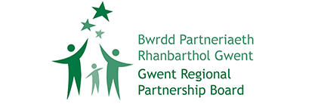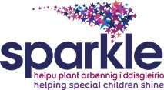

**NORTH GWENT CHILDREN’S CENTRE AND TRANSITION HUB**

**FEASIBILITY REPORT**

**PHASE 1**

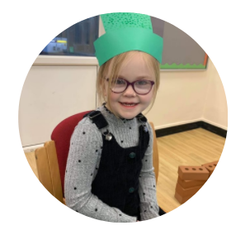

**Funded by Gwent Regional Partnership Board**

**Work conducted by Sparkle (South Wales) Limited**

**2023**

**Contents**

Executive Summary - PHASE 1 4

1. Phase 1 Section 1: Options appraisal 7

1.1 Children’s Centre 7

1.1.1 Option 1 – Continue to use Nevill Hall Children’s Centre 7

1.1.2 Option 2- Improve the facilities of the existing centre 7

1.1.3 Option 3 – Improve the facilities of the existing centre & operate from multiple other sites in a piecemeal way 8

1.1.4 Option 4 – Develop an integrated children’s centre in North Gwent 8

1.2 Transition Hub 9

1.2.1 Option 1 – Do nothing 9

1.2.2 Option 2 – Develop a Transition Hub in the north of Gwent 9

PHASE 1 - Definition of need 11

Introduction 11

2. PHASE 1, Section 2: The need for a new children’s centre 11

2.1 Existing provision 12

2.1.1 Serennu Children’s Centre 12

2.1.2 Caerphilly Children’s Centre 13

2.1.3 Nevill Hall Children’s Centre 13

2.2 Legislation and guidance 13

2.2.1 The Welsh Government 13

2.2.2 Gwent Regional Partnership Board 14

2.2.3 National Institute for Health and Care Excellence 15

2.2.4 The Children’s Commissioner for Wales 15

2.2.5 The Well-being of the Future Generations Commissioner for Wales 15

2.2.6 The United Nations Convention 16

2.2.7 Non-compliance with legislation and guidance 17

2.3 Children’s Centre consultation 18

2.3.1 Children, parents and carers 20

2.3.2 Professionals 21

2.4 Number of children receiving care and support with a disability 23

2.5 Referral boundaries 25

2.5.1 Consultation on boundaries 26

2.5.2 Relaxed boundaries 27

2.5.3 Travel 28

2.6 Equity of service 29

2.7 Conclusion 32

3. Phase 1, Section 3: The need for a Transition Hub 33

3.1 Existing provision 33

3.1.1 Local Authority 33

3.1.2 Health Board 33

3.1.3 Voluntary organisations 34

3.2 Legislation and guidance 35

3.2.1 The Welsh Government 35

3.2.2 Gwent Regional Partnership Board 35

3.2.3 National Institute for Health and Care Excellence 36

3.2.4 The Children’s Commissioner for Wales 36

3.2.5 Non-compliance with legislation and guidance 37

3.3 Transition Hub consultation 38

3.3.1 Young people, parents and carers 38

3.3.2 Professionals 39

3.4 Sparkle research 40

3.5 The Transition Hub 42

3.6 Conclusion 44

4. PHASE 1, Section 4: Scope of design 45

4.1 Introduction 45

4.2 Research and consultation 45

4.3 Room layout 47

4.4 Number of people attending the new North Centre 48

4.4.1 Numbers of children and young people and other users 48

4.5 The main elements of the building 49

4.6 The welcome/reception area 50

4.7 The Children’s Centre 51

4.8 The Transition Hub 53

4.9 Offices and meeting rooms 55

4.10 Shared facilities 55

4.11 Gardens, learning, play and horticulture areas 56

4.12 Parking 59

4.13 Lessons learned 59

4.14 Architect’s plans 60

4.15 Conclusion 65

Appendices 66

Appendix 1 – Who are Sparkle? 66

Appendix 2 - Case Studies: Nevill Hall Children’s Centre 66

Appendix 3 - Letters of support from families of children and young people with disabilities 66

Appendix 4 - Estimated numbers for the new Children’s Centre and Transition Hub 66

Appendix 5 - ICF Feasibility Proposal 66

Appendix 6 - Building requirements for the new Children’s Centre by service 66

Appendix 7 - Building requirements for the Transition Hub by service 66

Appendix 8 - Rooms at the new centre 67

Appendix 9 - Lessons learned from Serennu Children’s Centre 67

Appendix 10 - Consultation questionnaire 67

# **Executive Summary - PHASE 1**

Sparkle is a charity delivering care and support to children and young people with additional and complex needs in South Wales. At the core of this report is the detailed and extensive research and interviews carried out directly with these ***young people, their parents and carers to ensure they are ‘at the heart of all decision made' and will receive ‘equitable, joined up (planned and co-ordinated) services from each of the service providers’.***

We have therefore placed the families’ views and needs at the forefront of this project which aligns with the ABUHB, ISCAN and Partnership mission statement and priorities. In addition, the report takes full account of Welsh Government guidance on collaborative working, co-production and transition. In developing this feasibility report we have carefully considered the options available to ensure the delivery of an equitable, high quality service for the families of children and young people (CYP) with additional and complex needs in North Gwent.

The need for a new children’s centre in North Gwent is the focus of the first section of this report. The report finds that:

* A new fully integrated North Gwent children’s centre would benefit from being located close to the majority of the children and young people population it will serve (policy of care closest to home). Our study of population shows that a high proportion of children with disabilities and developmental difficulties in the north of Gwent live in North Torfaen and Blaenau Gwent areas **(82%).**
* Consultation exercises undertaken since 2019 found that *families and professionals* feel there is an inequity of service provision, and a need for levelling up in the north of Gwent in respect of services and facilities for children and young people with disabilities and developmental difficulties and their families, compared to that which is available in the south.
* A new integrated children’s centre located in Blaenau Gwent would bring enormous benefit to a high proportion of families, alongside wider economic and other benefits to this deprived area.
* These areas have significant pockets of deprivation, with families finding great difficulty travelling to the existing centre in Abergavenny, due to the timing and availability of public transport.
* A revised boundary configuration operated by the Health Board with reference to the children’s centre that families attend would support easier travel arrangements for families to their nearest children’s centre across Gwent.
* While staff operating from the current Centre in Nevill Hall hospital are highly qualified and committed professionals, the service they can deliver is significantly curtailed by the inadequacy of the current facilities.
* Sparkle’s research and consultation exercise has highlighted that the north of Gwent is not fully compliant with legislation and guidance which specifies the obligations and entitlements that statutory agencies must provide for disabled and developmentally delayed children and their families.

The conclusion of this section is that there is a need for a new fully integrated children’s centre in north Gwent, and that its location should be in Blaenau Gwent, close to the majority of children and young people that it will serve.

The second section of the report looks at the need for an integrated Transition Hub to serve the North catchment area with local services, and to provide an emerging model of improved collaboration between health, social care and voluntary services up to the age of 25 years, which could then be extended to the rest of Gwent, once model testing is completed. The report finds that:

* Communication and joint planning between agencies would be greatly improved with a North based Transition Hub which will facilitate the development of a model of improved collaboration across health, social care, and voluntary services for transition age children/young people. This would complement the 0-25 years approach taken by Blaenau Gwent Disability Services within social care, and be aligned with the ALN Code of Practice implemented by Welsh Government.
* There are growing numbers of young people who are eligible to access the support services offered by a Transition Hub.
* Many of the partner agencies recognise the gaps in transition provision and are keen to see an improvement in joined up child and adult health services.
* It is essential for the young adults and their families that a Transition Hub is sited alongside a children’s centre where the transition from child to adolescent services is more seamless and can be more easily facilitated.
* There is an on-going struggle by Gwent statutory agencies to meet the needs of young people at transition, resulting in young people and their families feeling confused and unsupported in the young person’s journey to adulthood.
* The development of ‘transition clinics’ run jointly by paediatric and health care staff would ease the YP’s transition. Social Care staff would welcome the opportunity to work more closely with health staff during the 15-24 year age group, facilitating joint planning etc.
* Sparkle’s research and consultation has highlighted that Gwent is not fully compliant with the legislation and guidance in respect of the need for effective transition services for young people with disabilities and or developmental difficulties transitioning from children to adult services.

The conclusion of this section is that Gwent does not currently meet the Welsh Government standards for transition of young people with complex needs, and that a Transition Hub would accelerate addressing the gaps in the current system, by developing a model of improved collaboration, including the development of transition clinics between paediatrics and adult health services. This service model which would be a first in Wales could then be implemented in other regions if the evidence suggests it is a successful model. Sparkle employ their own highly qualified Research Officer, and could undertake a thorough evaluation of new transition models being tested.

The third section of the report looks at the scope of design for a new children’s centre and Transition Hub. In summary:

* Following a consultation on the room and facilities requirements conducted with young people, families and professionals, a concept building design has been prepared.
* Clinics, therapies, training and activities will take place on the ground floor for easy access for those with mobility issues.
* Offices and meeting rooms for staff are on the first floor in a secure area, with appropriate facilities to account for new agile working, virtual appointments and confidentiality.
* The areas accessed by children, and transition aged young people (14-25 years) are located in separate wings, which is accessed by secure access-controlled corridors from the Children’s Centre and Transition Hub, thus avoiding any safeguarding issues.
* The Transition Hub has a separate entrance with its own independent setting within the building.
* There are multiple access points to the outdoor activity and garden areas, facilitating wellbeing activities for both families and staff.
* All lessons learned from the Serennu building have been accounted for in the design.
* An estimated 3.5-acre site is required for the project. This will be somewhat larger if considerable on-site parking is required, and smaller if not.
* Close proximity to facilities such as sports and leisure would reduce the site size further as facilities could be shared. The building footprint is estimated at 3,600m2.

The conclusion of this section is that the concept design will fulfil the requirements identified during consultations with stakeholders.

Finally, an options appraisal for a children’s centre and Transition Hub has been carried out with the following recommendations:

**Recommendation 1**

**It is recommended that the feasibility study progresses to the next phase on the basis of accepting there is a need for a new fully integrated children’s centre situated in Blaenau Gwent.**

**Recommendation 2**

**It is recommended that the feasibility study progress to the next stage on the basis of accepting there is a need for a Transition Hub in North Gwent which should be situated alongside a new fully integrated children’s centre.**

# **1. Phase 1, Section 1: Options appraisal**

# **1.1 Children’s Centre**

# **1.1.1 Option 1 – Continue to use Nevill Hall Children’s Centre**

Continuing to deliver services from the existing Nevill Hall Children’s Centre will sustain the long-standing inequity of service provision for families living in the north of Gwent compared to families living in the south. This difference will become even greater as the increasing demand for services will outstrip the limited facilities on offer, thus preventing many children and young people from being able to receive timely and appropriate interventions. Any expansion of services will be fragmented, piecemeal, inefficient and at disparate locations. **Crucially,** evidence within this report shows the current site is in the wrong location for the majority of children. This is not compliant with the requirements of legislation and guidance (ref. 1.3) set out to improve the care and support that children, young people and families receive. All statutory agencies have agreed that Nevill Hall Children’s Centre is no longer ‘fit for purpose’ and is not an integrated children’s centre with the necessary facilities to meet the needs of its current and projected increased population.

**Continuing to use Nevill Hall Children’s Centre is not recommended**

# **1.1.2 Option 2- Improve the facilities of the existing centre**

Our study of population shows that a high proportion of children with complex needs live in North Torfaen and Blaenau Gwent areas **(82%).** These areas have significant pockets of deprivation with families finding they are unable to travel to the existing centre in Abergavenny due to the time and availability of public transport. The study shows a very high percentage of those interviewed felt the current children’s centre was in the wrong location to fulfil needs. The existing centre has restricted facilities and no outdoor exercise area. In order to bring the centre up to the required standard, with appropriate indoor and outdoor facilities, similar to those available to children in South Gwent at Serennu, requires an estimated minimum of 3 acres. The Health Board have informed us that this land is not available at Nevill Hall.

**Making improvements to the existing facilities at Nevill Hall Children’s Centre is not possible due to site restrictions, and it is not in a suitable location for the populations needs (care closest to home), reinforcing the inequity in service provision and specifically disadvantaging the majority of families living in low-income areas. This conflicts with national guidance to ensure all children have equality of access to services.**

**Significant extension of facilities at the present site is not possible due to the site restrictions.**

**Significant improvement to the facilities at the existing centre is not possible or recommended.**

# **1.1.3 Option 3 – Improve the facilities of the existing centre and operate from multiple other sites in a piecemeal way**

* Professionals interviewed felt that co-location of services results in better outcomes for children they work with and better quality of life, better access to families, greater use of common processes. Saving time and money were outcomes has also been identified (Susan Booth, 2013)
* Co-location creates a ‘one stop shop’ for families with more joint appointments and less stress. Increased convenience for families has been cited in the literature as a benefit of co-location (Booth, 2013) and families have said that all services being located in the one building makes attending multiple or joint appointments easier (Sparkle, 2021)
* It is accepted that co-location results in a better service-user experience, where families have access to more services, better facilities and timely, efficient care.
* Co-location of leisure and support services with health and social care creates a more integrated holistic approach to care and all services being in one building allows children and families to become familiar with the environment, rather than being regularly introduced to new places and people (Sparkle, 2021)
* Integrated service provision improves the ability to safeguard children, due to the multi-agency perspective that is more easily accessible (Sparkle, 2019)
* Professionals from Serennu and Caerphilly Children’s Centres agreed that physical co-location of health and social care services in the same building, promotes multidisciplinary working, improves communication, avoids duplication and helps facilitate joint appointments.
* Professionals interviewed highlighted how co-location has resulted in time-saving, increased capacity and cost savings in terms of time and travel.
* Susan Booth (2013) evidenced that co-location creates a culture of improvement due to joint meetings, shared training, improved communication and information sharing.
* Co-location has also been found to promote greater awareness, appreciation and understanding of other roles and services (Booth, 2013).

**There is no evidence to support that a multi-site approach to care is in the best interests of children, young people and their families. The evidence to support co-location which results in a more integrated and holistic model of care is overwhelming, and consistent with WG guidance for greater integration of services. Piecemeal improvement of services at multiple locations is not recommended.**

# **1.1.4 Option 4 – Develop an integrated children’s centre in North Gwent**

Extensive consultation with a wide range of stakeholders and analysis of the population it will serve as detailed in this Phase 1 report has identified the need to develop a new integrated children’s centre, and that this should be built in Blaenau Gwent, where the majority of children served will be living. The work undertaken in this first phase of the feasibility study has highlighted;

* The long-term inequity of services that exists between the north and south of Gwent, which can only be rectified with a similar integrated facility to Serennu Children’s Centre
* The lack of compliance with legislation and guidance needed to meet need in North Gwent
* That a new integrated centre will improve collaboration between the agencies responsible for the holistic care of these children, enhancing outcomes for children and young people with disabilities and developmental difficulties and their families, while maximising the efficiency of the service providers. This is in contrast to the current service model, where not all of the staff working in clinics in Nevill Hall Children’s Centre can be based there, nor is there opportunity for joint working with social care staff. Professionals and parents wish that the long-term inequities in terms of life opportunities for children and young people with disabilities and developmental difficulties and their families in North Gwent, particularly those living in relative poverty, can be ended
* That a by-product of proposed relaxed health referral boundaries, and a new North Gwent centre will be to improve access to services for children in Caerphilly

**It is recommended that the feasibility study continue to Phase 3 on the basis of accepting the need for a new children’s centre in North Gwent.**

# **1.2 Transition Hub**

# **1.2.1 Option 1 – Do nothing**

Current piecemeal projects to assist with transition will continue with a variety of success and failure. Maintaining the current inefficient and ineffective processes not only fails to meet statutory requirements, but sets young people with a disability or developmental difficulty up to fail, thus placing an even greater burden on the health and social care services supporting them. This restricts and prevents young people from achieving their full potential.

**Doing nothing is not recommended**

# **1.2.2 Option 2 – Develop a Transition Hub in the north of Gwent**

This first phase of the feasibility study has shown that the development of a Transition Hub in the north of Gwent will advance the ability of the Health Board, in collaboration with local statutory agencies and the third sector, to meet legislation and guidance (ref 2.2) in respect of the transition of young people with disabilities and developmental difficulties from childhood to adulthood. This is high on the political agenda for Welsh Government and a Transition Hub, the first of its kind in Wales, will go a long way in addressing this priority. The study concludes that:

* An integrated Transition Hub will help to improve the life opportunities of young people in terms of their ability to develop independence and life skills in line with the opportunities available to their mainstream peers.
* There will be potential gains from testing a new model of care, enhancing collaboration between the Health Board, local authorities and the third sector, to meet the needs of YP aged 14-25 years.
* Offering much needed respite to carers and opportunities for the young people to gain volunteer/work experience reduces the risk of placement breakdown which can result in the young person requiring a very expensive out of county residential placement.
* The Transition Hub will help young people be part of a safe community, achieve independence and explore work experience opportunities.

**It is recommended that the feasibility study continue to Phase 3 on the basis of accepting there is a need for a Transition Hub in North Gwent.**

# **PHASE 1 - Definition of need**

# **Introduction**

This report is prepared by Sparkle (South Wales) Ltd ‘Sparkle’ (see Appendix 1), a charity, under the terms of the ICF Discretionary Capital Funding 2021-2022 Project Proposal, which specifies that the feasibility report will be submitted to the Regional Partnership Board.

This first phase introduces the reader to the need for a new integrated Children’s Centre to replace the existing Children’s Centre in the grounds of Nevill Hall hospital, Abergavenny in order to deliver equitable provision of services to children and young people (CYP) with complex needs in North Gwent. It also details the need for the development of a North-based Transition Hub to meet the needs of young people with complex needs from the age of 14 to 25 years. It specifies the provision from each of the existing three centres in Gwent, with reference to Welsh Government guidelines and standards relating to services for children and young people (CYP) with complex needs, and their families, highlighting where there is a failure to meet need and or relevant standards. It details the consultation exercise undertaken with children and carers, across the Health Board’s family and therapies division, together with professionals and managers within the local authority, social care and education department, and the voluntary sector. It deals with the scope of the building design including the services and facilities that have been identified through collaboration and consultation. Finally, it presents options for consideration by the Regional Partnership Board (RPB) for their decision.

# **2. PHASE 1, Section 2: The need for a new children’s centre**

This section looks at the existing provision for current and projected numbers of children (aged 0 to 18) with complex needs living in North Gwent. It provides a brief introduction and history of the Children’s Centres in Gwent. Current legislation and guidance are presented on the services required for children with complex needs. The report then illustrates the consultations carried out with stakeholders regarding what services and facilities they would like to see provided in North Gwent. It then addresses the current and projected number of children receiving care and support with a disability in Gwent. It considers the current boundaries in place that dictates which children’s centre a child goes to, and presents ideas for potential future boundaries, based on consultations carried out. In addition, travel times from areas across Gwent to both Nevill Hall, and a new potential centre location are explored. Finally, this section looks at equity of service between the North and South of Gwent, and what is needed to achieve this.

# **2.1 Existing provision**

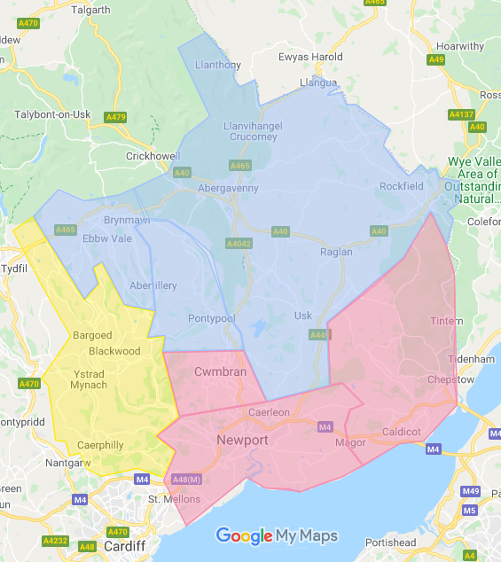

Map 1: Current boundaries imposed by the Aneurin Bevan University Health Board that determine which Children’s Centre a child attends

Therapies and other key services, e.g. outpatients, for children and young people with disabilities and developmental difficulties, are delivered from three children’s centre sites across Gwent:

* Serennu in the south serving Newport, South Torfaen and South Monmouthshire
* Caerphilly in the west serving Caerphilly borough
* Nevill Hall in the north serving Blaenau Gwent, North Torfaen and North Monmouthshire

# **2.1.1 Serennu Children’s Centre**

After 20 years of campaigning by Sparkle, following a report by parents and professionals (The Need is Obvious report 1991) the Serennu integrated centre in Newport was opened in 2011 to replace Eveswell Children’s Centre, which had been deemed ‘not fit for the purpose’ of delivering high quality therapeutic and other essential services to children with complex needs and their families in the Newport, South Monmouthshire and South Torfaen areas.

The integrated Serennu Children’s Centre provides a wide range of health services under one roof, and has driven integration and collaboration in the Newport area, by providing accommodation for Newport Local Authority’s children with disabilities team. In addition, it encompasses the third sector, via Sparkle and MediCinema, who utilise the facilities to provide ‘wrap around care’ to families of children with complex needs. The facilities in the centre include a hydrotherapy pool, a fully equipped ‘flat’ to develop independent living skills, a gym, a hydrotherapy pool, a rebound and bouldering facility, multiple therapy rooms, a range of clinic rooms, a sensory room, an audiology suite, outdoor play and sports facilities, a café for parents to meet, multiple meeting rooms and open plan office accommodation for health, social care, voluntary organisations and other professionals. In addition, the Centre is situated in its own landscaped grounds, outdoor play faci,ties, sensory paths, woodland walk and quiet reflective areas surrounded by trees and plants where either parents or professionals can go for their own wellbeing activities.

# **2.1.2 Caerphilly Children’s Centre**

The Caerphilly Children’s Centre was opened in 1991, the original building, which housed therapies and an assessment nursery, expanded over 31 years, to provide a rebound facility, hydrotherapy pool and some second-floor office accommodation for staff based there. Its location part way up a hill in the middle of a housing estate creates access issues from some families, andit has a limited range of services (see Table 7). Health Board paediatricians deliver their clinics from the Ysbyty-Ystrad-Fawr hospital and Trinity Fields school, as they consider the facilities at the Caerphilly Children’s Centre are inadequate for their clinics. This is an important issue in relation to the fragmentation of services. The relocation of local authority staff to other bases for a variety of different reasons has further reduced the opportunities for multi-agency working.

# **2.1.3 Nevill Hall Children’s Centre**

Nevill Hall Children’s Centre in the grounds of the hospital has been in place since 1991. It provides accommodation for therapists, child development officers, visiting Children and Adult Mental Health Services (CAMHS) professionals (pre Covid-19) and the helping hands psychology service. Care co-ordination services are run at all three children’s centres and are delivered from the building (funded from the Independent Care Fund “ICF”). There is no immediate access to any green space for either families or staff, in order to facilitate quiet reflection, or other wellbeing activities. Some staff who work in clinics here, eg ND nurses, cannot be accommodated onsite, and have to travel to and from Serennu for clinics.

**2.2 Legislation and guidance**

# **2.2.1 The Welsh Government**

Under the Social Services and Well-being (Wales) Act 2014[1], Part 9 statutory guidance (partnership arrangements) makes it clear that the RPB identifies priority areas for support, including people with *learning disabilities and children with complex needs* due to disability or illness. The Act also specifies the need for the development of co-operative organisations to provide care and support for children and adults. Similarly, under the Welsh Government’s ‘Improving Lives Programme’[2], a key requirement centres on improving **integrated social care and health care** for children with complex needs. The Welsh Government have also stressed the need for a person-centred approach to the care and support of children, which was seen as fundamental to the Social Services and Well-being (Wales) Act 2014.

The Additional Learning Needs (ALN) code for Wales 2021[3] provides a statutory framework for supporting children with additional and complex needs. Through the ALN framework, the Welsh Government has recommended that access to specialist advice and support for children in Wales be improved, for example through the availability of *therapies, sensory support and specialist support* for children and young people.

The Welsh Government have highlighted a need to address the *inequality in childcare* provision. A report by the Welsh Parliament Equality and Social Justice Committee[4] found that over the past year childcare provision for children with disabilities had decreased, with 38% of local authorities in Wales reporting insufficient childcare provision for children with disabilities.

The National Service Framework (NSF) for Children, Young People and Maternity Services in Wales (2004)[5] have laid out guidelines detailing the requirements for children with complex needs. These include, but are not limited to:

* Accessible play spaces and open accessible spaces for disabled children and their families
* Holiday activities and after school clubs that are accessible for children with complex needs
* Family support services that are responsive to their needs, are flexible and promote their inclusion in the local community
* Services that provide support and help parents applying for benefits e.g. the Disability Living Allowance
* Support and counselling sessions for parents and carers with children who have complex needs

# **2.2.2 Gwent Regional Partnership Board**

One of the emerging priorities to come out of the Gwent Regional Partnership Board (GRPB) Population Needs Assessment (PNA) [6] was the need for *earlier intervention, community-based support and placements closer to home* for children with complex needs. The report highlighted the need for more *‘meaningful activities’* that encouraged children to grow whilst also having fun. The report in particular highlights how children diagnosed with *autism* have struggled through the pandemic with loneliness and have needed more *support and meaningful activities*. The PNA recommends better access to support services for those with Autistic Spectrum Disorder. Another recommendation the PNA gave, was to increase public awareness and understanding of people with disabilities, through disabilities services having a more active role within the community.

The GRPB have also recommended that there be a shift towards ‘social value-based commissioning’ which ensures well-being for people. According to the GRPB guidance, this will help ensure the inclusion and growth of *not-for-profit* organisations in delivering social value and working *in co-production* with other sectors.

Another key recommendation to come out of the PNA was the need for support services that can provide **respite for carers**. The pandemic has been damaging on carers’ mental health with many feeling stressed and anxious. As a result, the GRPB have found that ‘respite is continually highlighted as the highest support need for carers across Gwent’. For every child with complex needs there is at least one parent who is a carer.

# **2.2.3 National Institute for Health and Care Excellence**

The National Institute for Health and Care Excellence (NICE)[7] have issued guidance relating to community support for children with disabilities. This includes involving partnership with other commissioners and service providers in the voluntary sector in order to ensure specialist care and disability support services remain in the community. NICE guidelines also specify the need for family advocacy, family support and information groups that offer skills training and emotional support for families, parents and carers.

# **2.2.4 The Children’s Commissioner for Wales**

The Children’s Commissioner for Wales, in her report ‘No Wrong Door’[8] has stated that currently children are ‘bounced’ between services given that there is often no one service that can cover the complex needs many children have. This, according to the report, is causing children emotional distress, given that they must deal with complicated systems. The commissioner has recommended a system change as well as **long term strategies** in order for children to feel fully supported, which she felt could be achieved through integrated teams, and hub models.

# **2.2.5 The Well-being of the Future Generations Commissioner for Wales**

The Well-being of the Future Generations (Wales) Act (2015) was implemented in April 2016 and looks to progress the environmental, social, economic and cultural well-being of Wales. A key aim of this Act is to ensure public bodies think about the long-term, for example when it comes to access to health and social care services. The Act also looks to create a more **joined-up approach between agencies**, and ensure people and communities work better together. The Commissioner has also stated guidance in her 2020 report, which recommends that ‘quality of health and access to health care services should be equal across groups, and should not be affected by their ethnicity, gender, sexual orientation, disability or relative poverty they live in’.[9]

**2.2.6 The United Nations Convention**

Under the Rights of Children and Young Persons (Wales) Measure 2011, the Welsh

Government has a duty to regard the policies stated in the United Nations Convention on the Rights of Persons with Disabilities (UNCRPD). Under the UNCRPD, health services are required to provide services *as close as possible to peoples own communities*, including in rural areas. The Convention also stated the need to ensure that *children with disabilities have equal access with other children to leisure, play and sporting activities*.

# **2.2.7 Non-compliance with legislation and guidance**

**Table 1: Summary of current legislation and guidance and non-compliance in respect of existing North Gwent provision**

|  |  |
| --- | --- |
| **Guidance or Legislation** | **Current North Gwent Provision** |
| Social Services and Well-being (Wales) Act 2014 | Children in North Gwent must travel to different locations to access health provision, social care and leisure services, as opposed to an integrated centre, such as the integrated Serennu Children’s Centre, which offers all these services in one place to children in the south. |
| The Additional Learning Needs (ALN) code for Wales 2021 | Nevill Hall Children’s Centre offers therapy services, however it does not offer other specialist therapy and sensory facilities, such as a fit for purpose hydrotherapy pool, rebound, bouldering, a sensory room and sensory garden, which are offered at the integrated Serennu Children’s Centre. |
| The Welsh Parliament Equality and Social Justice Committee | Nevill Hall Children’s Centre does not offer any specialist activities or clubs such as after school club, play club or skills club, which are currently on offer at the integrated Serennu Children’s Centre, and tailored to children with complex needs. |
| The National Service Framework (NSF) for Children, Young People and Maternity Services in Wales (2004) | Services that would meet these needs, such as specialist places, spaces and equipment[10], purpose-built leisure facilities, and after school clubs for children with complex needs, are not available at Nevill Hall Children’s Centre. Children and families in North Gwent must therefore travel to numerous different locations to access specialist facilities for sport, leisure and training activities and clubs. |
| Gwent Regional Partnership Board (GRPB) Population Needs Assessment (PNA) | Given that Nevill Hall Children’s Centre is located on a hospital site, and there are no social or leisure activities offered on site, this does not give the children who attend the centre an opportunity to meet other children with shared experiences. |
| The National Institute for Health and Care Excellence (NICE) | Nevill Hall Children’s Centre does not provide any skills clubs for children with complex needs. |
| The Children’s Commissioner for Wales | North Gwent does not have an integrated Children’s Centre that offers the co-location of health, social services and education and leisure services, who all provide services from multiple sites, thus maintaining a ‘silo’ approach to care. |
| The Well-being of the Future Generations Commissioner for Wales | The current Children’s Centre in North Gwent does not provide a long-term solution to care services. Given the size of the centre, it does not account for growth in the number of children with disabilities needing support. It’s location in Monmouthshire, with poor public transport links to Blaenau Gwent discriminates against the large number of families living in poverty there. |

# **2.3 Children’s Centre consultation**

In identifying the need, consultations were carried out with parents and carers who have a child with complex needs, children and young people with complex needs, and professionals from health, education, social care and third sector organisations.

Sparkle became the lead charitable partner for Nevill Hall Children’s Centre in May 2019, and had already conducted research into the unmet needs of children and families living in this catchment area, summarised in ‘The views of parents and professionals on Sparkle’s delivery of new services for children with additional needs and their families in North Gwent’.[11]

A total of 100 parents and 30 professionals completed questionnaires, and 5 parents and 9 professionals also took part in focus groups.

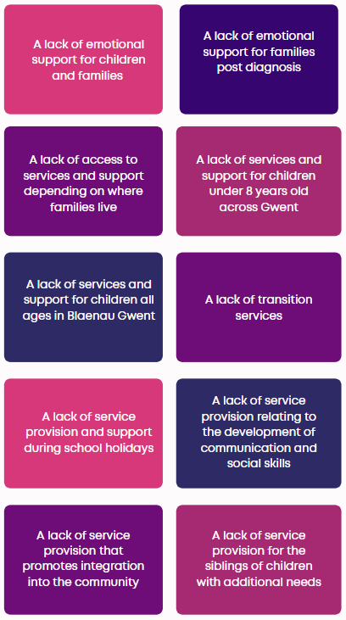**Figure 1: Summary of findings from consultations with parents and professionals on the current provisions for children with complex needs in North Gwent**

The Sparkle report: ‘Consultation with families and professionals in North Gwent on the need for a new children’s centre for children and young people with disabilities and or developmental difficulties’ (2021)*[12]* highlighted the view of families that there is a desperate need for a new integrated children’s centre in North Gwent.

The consultation for this research report was conducted in three stages:

* Questionnaires were sent to families with a child who had complex needs and to professionals working with children with complex needs
* Interviews and focus groups were then conducted with professionals and families
* A poster competition was sent to children and young people with complex needs in order to incorporate their views on a new centre

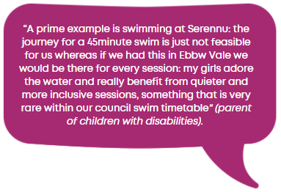

This report revealed that most professionals considered the Children’s Centre at Nevill Hall no longer fit for purpose. This was due to the site lacking in the following:

* space
* resources
* facilities

Both families and professionals referenced the difficulty families from Blaenau Gwent face in accessing services due to the lack of effective public transport in the area. The consultations also identified a need for support services for the families of children with complex needs. This demonstrates that in order to achieve ‘levelling up’, the optimal location for a new children’s centre is Blaenau Gwent, given that this will address the existing inequity against the 57% (see table 4) of children coming from this area of high deprivation, with far greater reliance on public transport.

Further consultation was carried out between June and October 2021 and consisted of individual and group interviews with relevant stakeholders. A standardised format was used to guide each consultation, with explicit themes to be explored. The aim of the consultations was to gain an in-depth perspective of the needs and preferences of each of these stakeholders in regards to the facilities, location, access and services they would like to see in North Gwent for an integrated children’s centre and Transition Hub.

Within the health sector 16 professional groups and 34 individual professionals were consulted for their views and ideas on facilities and location of a new children’s centre in North Gwent. Extensive consultation also took place within social care, education and third sector.

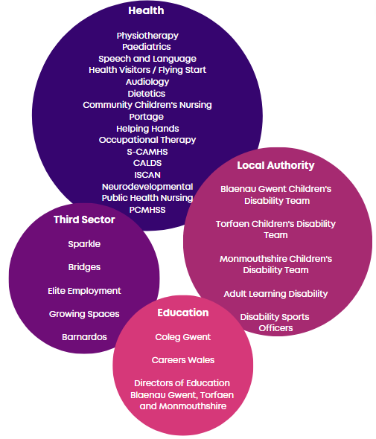

**Figure 2: Stakeholders consulted for their views on the new Children’s Centre and Transition Hub**

# **2.3.1 Children, parents and carers**

In addition to consultation with professionals and representatives from key organisations, a design competition was sent out to children asking them to design their own children’s centre, with a specific art theme of their choosing. This produced many detailed designs, giving an insight into what children would like to see in a new integrated children’s centre.

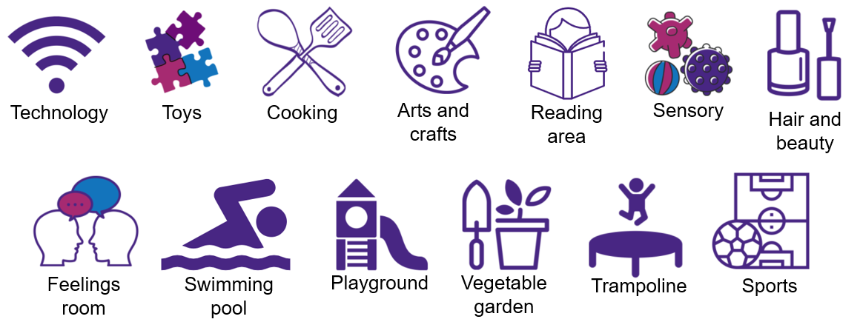

**Figure 3: Summary of what children wanted at a new integrated children’s centre**

Children from disability support groups in Blaenau Gwent were also asked to provide ideas of what they wanted to see at a new centre.

Suggestions included:

* Theatre classes
* A café
* Music/singing club
* Dance club
* Bingo nights
* Table tennis
* Owl sanctuary
* Pizza night
* Board game club

# **2.3.2 Professionals**

The consultation identified the following as the key priorities for professionals in relation to improvements to North Gwent provision:

* Equitable service provision
* More fluid workforce
* Rationalised health boundaries
* Enhanced links with education and social services
* Relocate Ysbyty Aneurin Bevan clinics (paediatric)
* Closer integration with Primary Care Mental Health Support Services (PCMHSS) and CAMHS
* ISCAN to contribute to co-ordinated service delivery in the North

The consultations also revealed what professionals believe to be future priorities for a new children’s centre:

* Working with mainstream facilities
* Co-location
* Hot desking
* Blended virtual and face-to face facilities
* Interactive technology for assessment and treatment
* Good transport links
* Facilities for collaboration

**Figure 4: Services and facilities requested by professionals during consultation**

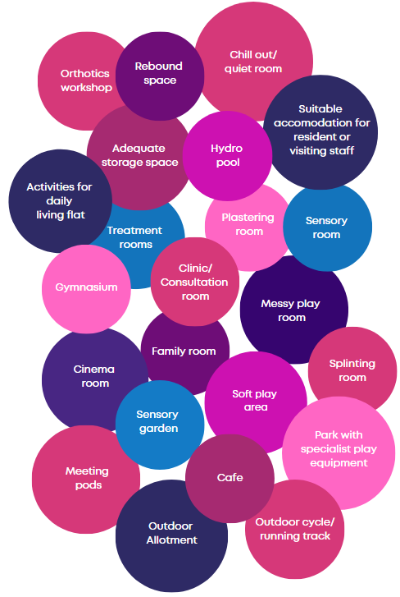

Many of the priorities mentioned by professionals are in line with recommendations and requirements published by the Welsh Government through ISF standards, the ALN code and the Social Services and Well-being (Wales) Act. *For example, equitable service provision, a more fluid workforce, better links between health, education social services and the third sector, co-location of services and good transport links*.

This section of the report has addressed the consultations carried out with stakeholders regarding what services and facilities they would like to see provided in North Gwent, and has clearly identified what services and facilities are required to provide an equitable service between north and south Gwent.

# **2.4 Number of children receiving care and support with a disability**

A research report was conducted by Sparkle[13] into the estimated number of children in Gwent receiving care and support with a disability. This found that there has been a minimum of 1.5% increase in children with a disability receiving care and support in Wales as a whole between 2017 and 2019. Houtrow et al. (2014)[14] also found that there was a 15.6% increase in parent-reported childhood disability between 2001/2002 and 2010/2011, and neurodevelopmental disability increased by 20.9% over the 10 years.

However, looking only at the number of children with a disability receiving care and support in local authorities *in Gwent*, there was a *10.6% yearly* increase between 2017 and 2020, which is significantly higher than the Wales average. It is important that this study does not underestimate the number of children who will require the Children’s Centre services in the area it supports, therefore the study assumes there will be a **106% increase in childhood disability** over the next 10 years, in line with the average yearly increase for Gwent.

**Table 2: Yearly increase in children receiving care and support with a disability in Wales and Gwent[15]**

|  |  |  |
| --- | --- | --- |
|  | **Wales** | **Gwent** |
| 2017 | 3,455 | 375 |
| 2018 | 3,435 | 405 |
| 2019 | 3,575 | 485 |
| 2020 | 3,600 | 505 |
|  | **On average, 1.4% increase a year** | **On average, 10.6% increase a year** |

This yearly increase will put additional pressure on Gwent children’s services and on Nevill Hall Children’s Centre, a building which already has extremely limited capacity and services. However, the development of an integrated children’s centre in North Gwent would ensure all children with disabilities have their health and social care needs met, and none are overlooked, thus removing inequalities and ‘levelling up’ the provision in North Gwent.

Based on the boundaries map and the postcodes of children/young people accessing Sparkle clubs in the South and North, it has been evaluated that the following postcodes make up the catchment areas. The data defines each postcode by whether it has a high or low population[16] to help estimate numbers for Torfaen and Monmouthshire, which are split into north and south.

**Table 3: Postcodes that make up the south, north and west catchment areas**

|  |  |
| --- | --- |
| **South/Serennu catchment area** | |
| Newport | NP10 (mid population); NP18 (low population); NP19 (very high population); NP20 (very high population) |
| South Torfaen | NP44 (very high population) |
| South Monmouthshire | NP16 (mid population); NP26 (mid population) |
| **North/Nevill Hall catchment area** | |
| Blaenau Gwent | NP13 (mid population); *NP22 (mid population, only half in Blaenau Gwent)*; NP23 (high population) |
| North Torfaen | NP4 (very high population) |
| North Monmouthshire | NP7 (mid population); NP15 (low population); NP25 (low population) |
| **West/Caerphilly catchment area** | |
| Caerphilly | NP11 (high population); NP12 (high population); *NP22 (mid population, only half in Caerphilly)*; NP24 (low population); *CF46* *(low population, only half in Caerphilly);* CF81 (low population); CF82 (mid population); CF83 (very high population) |

Based on the above current referral boundaries set by the Aneurin Bevan University Health Board (ABUHB), there are an estimated minimum 339 children with disabilities receiving care and support in North Gwent.

**Table 4: Estimated number of children with a disability receiving care and support by catchment area**

|  |  |
| --- | --- |
|  | Estimated number that attend the Children’s Centres, based on the number of children with a disability receiving care and support and number of children with ASD |
| **South/Serennu catchment area** | **830** |
| Newport | 514 |
| South Torfaen (60%) | 126 |
| South Monmouthshire (75%) | 190 |
| **North/Nevill Hall catchment area** | **339** |
| Blaenau Gwent | 192 |
| North Torfaen (40%) | 84 |
| North Monmouthshire (25%) | 63 |
| **West/Caerphilly catchment area** | **423** |
| Caerphilly | 423 |

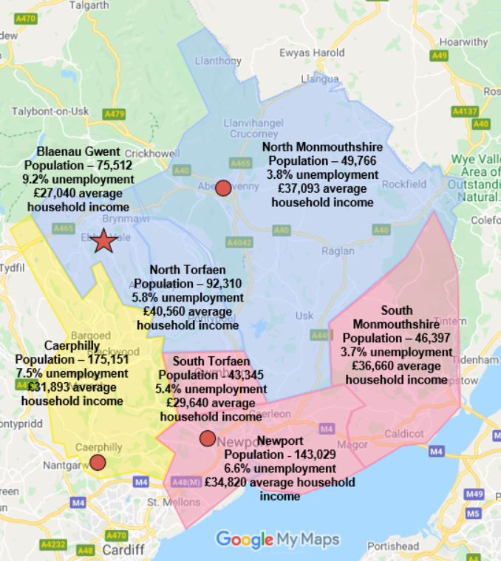From the table above it can be seen that *57%* of the children with disability accessing care and support services in North Gwent live in *Blaenau Gwent*. In comparison 25% of the children accessing these services live in North Torfaen and 18% in North Monmouthshire. These figures demonstrate that the need for a new integrated children’s centre is most prevalent in Blaenau Gwent and North Torfaen, given that the majority of children attending the Children’s Centre will be from this area (82%).

Map 2: Population, unemployment rate and average household income across Gwent

The above map shows the population, unemployment rate and average household income in catchment areas across Gwent. The map demonstrates that the highest rate of unemployment is located in Blaenau Gwent, where the rate is 9.2%. In Blaenau Gwent the average household income is £27,040, which is the lowest of the Gwent catchment areas, illustrating that this is an area of higher deprivation, and thus has highest reliance on public transport for travel to a children’s centre.

# **2.5 Referral boundaries**

Referral boundaries imposed by Aneurin Bevan University Health Board (ABUHB) determine which children’s centre a child attends, and were defined over 30 years ago. In the 30+ years that these referral boundaries have been in place, there have been huge changes to the transport infrastructure, and housing density across Gwent.

# **2.5.1 Consultation on boundaries**

The topic of boundaries came up during research and development work completed by Sparkle, both in consultations with families and professionals in Caerphilly (2021)[17], and in North Gwent (2021)[18].

The key findings from the Caerphilly consultation (2021) are as follows:

* Many families did not have access to transport and felt it would be easier if they were able to attend the Children’s Centre nearest them
* Families living near the Caerphilly-Blaenau Gwent border felt it would be easier for them to attend activities in Blaenau Gwent rather than Caerphilly, but they weren’t able to due to the catchment
* Professionals felt that whatever was best for the families is what should be done

The topic of boundaries also emerged in the North Gwent consultation (2021). Some of the professionals consulted felt that leisure services should be provided ‘closer to home’.

In both reports, families and professionals suggested that families would benefit from being able to access the Children’s Centre that was most convenient to them.

In response to these findings, Sparkle conducted further consultations with professionals, young people and parents/carers about their opinions on the current boundaries imposed by ABUHB.

The key findings from consultations with *professionals* around boundaries are as follows:

* There was support amongst professionals for changing the traditional boundaries to facilitate flow across three children’s centres which complement each other
* Professionals felt choice for families is important, meaning the current boundaries need to be looked at, and possibly relaxed
* However, professionals also felt that boundaries needed to be agreed by the whole multidisciplinary team

Given that it is estimated over half of the children (57%) accessing services at the new Children’s Centre are from Blaenau Gwent, professionals identified this as an area of need. In addition, families in the North of Torfaen, travelling to Nevill Hall Children’s Centre have told us that this is a difficult location to access. The consultations found that professionals overwhelmingly supported the idea of a new children’s centre in Blaenau Gwent, and a clear commitment to the delivery of an equitable service for all children, young people and families in Gwent. In addition, in depth information from professionals about the site, location and requirements for a new centre (see Section 4: Scope of design) has helped this part of the study.

# **2.5.2 Relaxed boundaries**

In response to the consultation findings, Sparkle has researched the implications of relaxing the current boundaries to allow families to access their most convenient children’s centre.

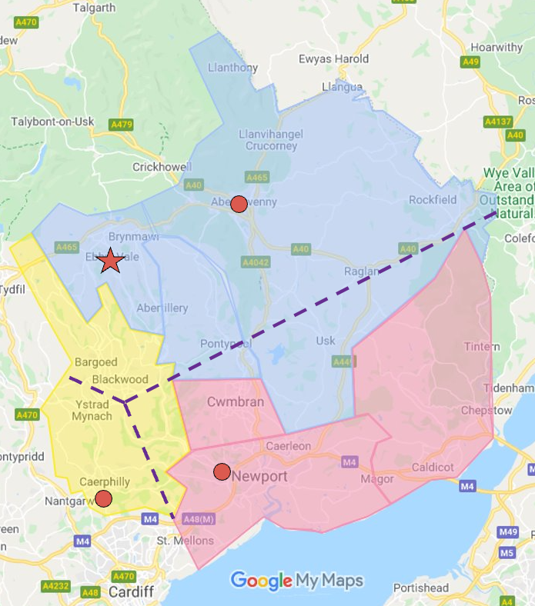The following is a map showing the proposed relaxed boundaries.

Map 3: Proposed relaxed boundaries against the current ABUHB boundaries

The following is an estimation of the current number of children likely to attend each children’s centre, if the present boundaries were relaxed to allow families to access their most convenient children’s centre.

**Table 5: Estimated number of children that would attend the Children’s Centres based on relaxed boundaries**

|  |  |  |
| --- | --- | --- |
|  | Postcodes | Estimated number that would attend the Children’s Centres |
| **South/Serennu catchment area** | | **884** |
| Newport | NP10; NP18; NP19; NP20 | 514 |
| Torfaen (60%) | NP44 | 126 |
| Monmouthshire (80%) | NP15; NP16; NP26 | 202 |
| Caerphilly (10%) | NP11 | 42 |
| **North/Nevill Hall catchment area** | | **496** |
| Blaenau Gwent | NP13; NP22; NP23 | 192 |
| Torfaen (40%) | NP4 | 84 |
| Monmouthshire (20%) | NP7; NP25 | 51 |
| Caerphilly (40%) | NP22; NP24; CF81 | 169 |
| **West/Caerphilly catchment area** | | **212** |
| Caerphilly (50%) | NP12; CF46; CF82; CF83 | 212 |

As the above table demonstrates, if the current boundaries were relaxed, 157 (40%) of the children located in the far north of Caerphilly could attend a new centre if it were to be situated in Blaenau Gwent. This would ease the pressure on Caerphilly Children’s Centre, given that more children would be attending the new North Gwent Children’s Centre, which would have the capacity to cater for the forecast increase in number of children with complex needs.

# **2.5.3 Travel**

The approximate time it would take for families from across North Gwent, and part of Caerphilly, to travel to Blaenau Gwent and Nevill Hall has been summarised below. The North Gwent location on the Ebbw Vale Works site was chosen as a comparator based on the location of those who participated in Sparkle’s consultation into the need for a new centre. Times have been taken from Google Maps, set to depart at 10am on a Monday, and may vary depending on the time of day.

**Table 6: Table comparing approximate time taken to travel to Ebbw Vale Works site and Nevill Hall**

|  |  |  |  |  |
| --- | --- | --- | --- | --- |
| **Location** | **Ebbw Vale Works site** | | **Nevill Hall** | |
| **Approximate time taken by car** | **Approximate time taken by public transport** | **Approximate time taken by car** | **Approximate time taken by public transport** |
| Blaenau Gwent | | | | |
| Ebbw Vale | 1-10 minutes | 1-10 minutes | 26-35 minutes | 1 hour |
| Abertillery | 12-16 minutes | 47 minutes | 26-35 minutes | 1hr 17minutes |
| Blaina | 14-18 minutes | 36 minutes | 24-30 minutes | 1hr 6 minutes |
| Nantyglo | 12-16 minutes | 28 minutes | 22-28 minutes | 59 minutes |
| Tredegar | 9-12 minutes | 12 minutes | 30-40 minutes | 1hr 10 minutes |
| Torfaen | | | | |
| Pontypool | 22-28 minutes | 1hr 9 minutes | 20-26 minutes | 49 minutes |
| Talywain | 22-28 minutes | 1hr 2 minutes | 20-26 minutes | 1 hour |
| Little Mill | 26-35 minutes | 2hr 14 minutes | 16-22 minutes | 48 minutes |
| Blaenavon | 16-22 minutes | 43 minutes | 14-18 minutes | 1hr 12 minutes |
| Monmouthshire | | | | |
| Abergavenny | 22-28 minutes | 1hr 8 minutes | 1-10 minutes | 13 minutes |
| Monmouth* | 35-50 minutes | 2hr 48 minutes | 22-35 minutes | 1hr 2 minutes |
| Usk* | 35 minutes | 2hr 18 minutes | 20-26 minutes | 1hr 54 minutes |
| Triley | 22-30 minutes | 1hr 50 minutes | 8-12 minutes | 30 minutes |
| Caerphilly | | | | |
| Rhymney | 14-18 minutes | 57 minutes | 35-45 minutes | 1hr 54 minutes |
| Brithdir/New Tredegar | 20-28 minutes | 1hr 33 minutes | 40-55 minutes | 2hr 35 minutes |
| Bargoed/Aberbargoed | 22-26 minutes | 1hr 23 minutes | 40-55 minutes | 2hr 17 minutes |
| Pentwyn | 16-22 minutes | 1hr 27 minutes | 35-45 minutes | 2hr 25 minutes |
| Blackwood | 18-24 minutes | 54 minutes | 35-45 minutes | 1hr 40 minutes |

*Public transport routes from these locations involve travelling through Newport.

The above table demonstrates that locating the new centre in Ebbw Vale, could save families living in Blaenau Gwent, which represent 57% of users, a significant amount of travel time, both by car and public transport. Time difference for families living in North Torfaen are not significant. For families in Monmouthshire, there will be longer public transport travel times, but this area has a higher proportion of vehicles per household (see Appendix 4), and with the relaxed boundaries those travelling to Serennu Children’s Centre will not see significant additional travel times.

# **2.6 Equity of service**

Families have compared what is available from the integrated Serennu Children’s Centre to what is available in the Nevill Hall Children’s Centre, and have expressed their frustration about the inequities that exist. The size and scope of facilities at the Nevill Hall Children’s Centre is limited, its location is in hospital grounds rather than a community site, and it is extremely poorly served by public transport, particularly from Blaenau Gwent. Delivery of services are limited in the following ways:

1. It does not have a fit for purpose hydrotherapy pool, rebound facility or sensory room
2. Existing accommodation is overcrowded for all professional groups housed in the building, limiting current provision
3. There is little scope to deal with increased demand
4. Treatment facilities are extremely limited
5. Public transport from sites of large population in Blaenau Gwent, e.g. Ebbw Vale, Tredegar can take over two hours one way to Nevill Hall
6. Parking is an issue for all families and limits access to the centre
7. Parking is an issue for all staff based in the centre, and they report how much time is wasted looking for parking spaces in the hospital car park
8. The current facilities do not allow for the development of enhanced leisure activities, and do not have access to appropriate outdoor play or sports facilities
9. The current building does not allow for co-location of any local authority, social care, education or voluntary sector professionals, and therefore does not support an integrated service delivery model
10. Details in table 7 delineate specific inequity in specialist support and facilities
11. By being on a hospital site, rather than a community site, this centre reinforces a ‘medical model’ of disability, which is in direct conflict with the internationally recognised ‘social model’, aimed at recognising children’s wider emotional, social and developmental needs

**Table** **7** below shows what facilities exist in each children’s centre, and what services are delivered from each of the centres, highlighting the inequity within the existing service provision.

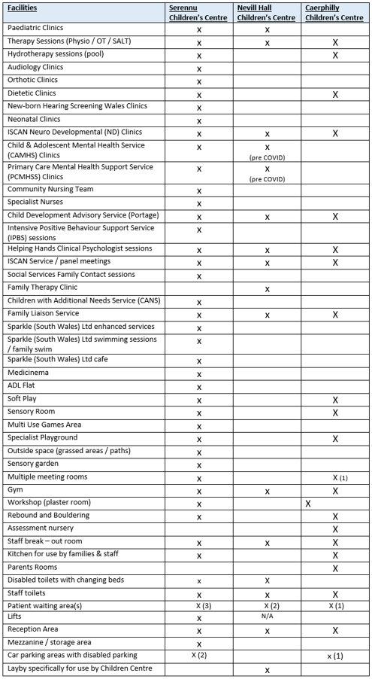

**Table 7: Comparison of Children Centre Facilities across Gwent: Serennu / Nevill Hall / Caerphilly**

The Sparkle report (2021), through the evidence given, reiterates that there is inequity across Gwent when it comes to access to health, social care services and leisure activities for children with complex needs. The **ICF Discretionary Capital Funding 2021-22 Project Proposal[19]** outlines the services offered to children and young people accessing the integrated Serennu Children’s Centre and the comparatively limited services and facilities offered by Nevill Hall Children’s Centre. The ICF proposal states:

*“Clearly, the children in North Gwent face exactly the same challenges and problems with their health as children in the south of Gwent, with huge difficulties accessing appropriate play and leisure provision, in an area of high deprivation and covering a large geographical area. However, they are provided with a completely inequitable service through the existing facilities, which only meet some limited health needs and no social care or leisure needs”.*

In regard to ‘**levelling up’ the north,** the **Project Proposal** stated that the first of its two key aims was to *“address the inequity of services to children with complex needs across Gwent, by developing a detailed plan for a fully integrated children’s centre in North Gwent, as currently exists in South Gwent”.*

The project proposal further describes what families have repeatedly told us that they want and need *“access to a centre that meets all of their child’s complex needs in one location, instead of the current situation where they have to travel to one site for health support, a different site to access social care and yet another site for some limited leisure provision”.*

In respect of a broader social and economic ‘**levelling up’** the **ICF Discretionary Capital Funding 2021-22 Project Proposal** anticipates the project will bring the following benefits:

* Improved co-ordination between the Health Board, the relevant Local Authority teams to speed up and improve decision making
* Direct cost savings from co location of the Health Board, Local Authority and voluntary organisations (leisure services, supporting social and emotional development & family support) in respect of travel cost and time, meeting times, more efficient use of resources, improved dialogue between parties, reduced duplication of service provision
* A new integrated children’s centre is likely to attract skilled employment and national interest, and help jump start improvements to disabled children’s lives in other areas

From the information provided, it can be concluded that there is inequitable service provision in Gwent. Evidence demonstrates that North Gwent is under-provided for when it comes to key services and facilities, as seen on **Table 7**.

# **2.7 Conclusion**

This section of the Phase 1 study has looked at the need for a new fully integrated children’s centre in North Gwent. It has concluded that;

* The north of Gwent is not compliant with legislation and guidance which specifies what disabled and developmentally delayed children, young people and their families are entitled to and what the statutory agencies are obligated to provide
* Families and professionals feel there is inequity of service and a need for levelling up in the north of Gwent in respect of services and facilities compared to what is available in the south. Consultation exercises undertaken since 2019 support this
* There are growing numbers of children in North Gwent who currently do not have, and thus require access to, a comprehensive and integrated service delivery
* A new fully integrated North Gwent children’s centre would benefit from being located close to the majority of the population it will serve
* The Children’s Centre should not be located in a hospital setting
* A revised boundary configuration would support easier travel arrangements for a great number of families
* There are significant discrepancies in terms of services and bespoke facilities that are available to children and young people with disabilities and developmental difficulties and their families living in the north of Gwent compared to the south
* A new integrated children’s centre located in Blaenau Gwent would bring potential enormous benefit to a high proportion of families and to this local area

The conclusion of this section is that **there is a need** for a new fully integrated children’s centre in North Gwent and that **its location should be in Blaenau Gwent** close to the majority of children it will serve.

# **3. Phase 1, Section 3: The need for a Transition Hub**

# **3.1 Existing provision**

Existing provision of transition services for young people in Gwent is offered by individual organisations, charities and local authorities. Many of these services vary greatly in terms of the type of support offered, and can also vary depending on the type of disability the young person has and their location.

# **3.1.1 Local Authority**

The five Gwent Local Authorities within the ABUHB catchment area have published the ‘Pan-Gwent Multi-Agency Transition Protocol for Young People with Disabilities and/or Additional Learning Needs’[20] which details the current government protocol in place for young people in Gwent who are in transition. Within the joint publication, Monmouthshire County Council, Torfaen County Borough Council, Blaenau Gwent County Borough Council, Caerphilly County Borough Council, Newport City Council, ABUHB and Careers Wales committed to offer the following transition services:

* A social worker or specialist health professional will act as a young person’s ‘Transition Coordinator’ as the young person leaves school and moves into adulthood
* The Transition Coordinator will ensure the young person has a Multi-Agency Transition Group, with contributions from a Careers Wales advisor and the school
* A Health Board representative on the Multi-Agency Transition Group will identify the health professionals the young person may need

All five local authorities within Gwent offer a disability team. Monmouth Council and Newport Council have separate children disability teams, and adult learning disability teams, whereas Blaenau Gwent, Caerphilly and Torfaen councils have combined child and adult teams. Blaenau Gwent Council employ a dedicated disability team, which includes transition workers who offer support to young people on how to smoothly transition to adult services. They also offer advice around registered charities and support meetings to ensure young people are achieving their potential plan outcomes their plan. Newport Council employ a dedicated transitional planning officer who will assess a young person’s transition needs and offer support. Monmouthshire, Caerphilly and Torfaen council do not employ a transition officer, but their disability team offer transition services, including financial support, signposting services and community events.

# **3.1.2 Health Board**

In the ABUHB annual plan (2021-2022)[21] there is a ‘transition pathway’ for 15 to 25 year olds. The annual plan outlines a strategy to ‘increase opportunities for service user participation and co-production of treatment and transition pathways’. The Health Board have also created a CAMHS participation group which was piloted in 2021, allowing young people to actively participate in the transition process.

The Health Board also provide Advanced Care Plans (ACPs) for young adults in times of transition. They plan to make these electronic in order to make them easily accessible to patients, their carers, clinicians and ambulance staff in order to ensure decision making surrounding a young person’s transition is well-informed.

# **3.1.3 Voluntary organisations**

**Table 8: Voluntary organisations offering transition services in Gwent**

|  |  |
| --- | --- |
| **Voluntary Organisation** | **Transition support offered** |
| **Dimensions** | Dimensions work specifically with people with learning disabilities, autism and complex health needs and some of their services are located in Blaenau Gwent, along with other services run across England and Wales. They offer transition services to young people between the ages of 19-25. They offer the following services:   * Life skills * Help with supported living * Helpline for families * Help finding employment |
| **The Building Bridges project** | Situated in Monmouthshire, the project offers activities and work-related experiences to young people with additional needs between the ages of 14-25. Building Bridges are involved in regular youth clubs, drama and dance groups, swimming groups, football groups and golfing sessions. |
| **Gwent Integrated Autism Service (IAS)** | IAS offer drop-in sessions for young people in transition, however this service is specifically for young people with autism who are aged 18+. During these sessions the IAS team will provide support and advice for autistic adults and young people, parents/ carers, and professionals. |
| **Autistic Spectrum Disorder (ASD) support** | ASD support work only in Torfaen, offering to work with young people with ASD in collaboration with that person’s school, family and allied professionals. They also offer transition support to young people with ASD, which is done through a tailored package of support based on individual needs, ability and interest. |
| **National Youth Advocacy Service (NYAS)** | This serviceprovides advocacy and legal representation for young people up to the age of 25 who have a disability who are subject to child protection plans, have mental health difficulties or whose parents are separating. |
| **The Torfaen Young People’s Counselling Service** | This counselling service offers therapy to young people between the **ages of 7-19** across all schools located in the borough of Torfaen. |

# **3.2 Legislation and guidance**

# **3.2.1 The Welsh Government**

Previous Welsh Government policy has underpinned the transition process: The National Service Framework (NSF) for Children, Young People and Maternity Services in Wales (2004) [22] and the Special Educational Needs (SEN) Code of Practice in Wales (2004)[23] have all laid out the fundamental needs in terms of identification of young people requiring support during transition, family support, inter-agency collaboration & transition planning. The NSF have stressed that many young people with complex needs are excluded from adult services, or experience a **decline in the services** they receive. In line with The United Nations Convention on the Rights of the Child, the SEN code of practice documents that every child, including those with disabilities, has the right to participate in the decision-making process about their education and future.

A report by the Welsh Government on the Additional Learning Needs (ALN) code for Wales (2021)[24] has also highlighted that early and **co-ordinated** transition services for young people with complex needs is best practice, given that this can be tailored to suit the individual person’s needs.

The Welsh Government have also recently published the Transition and Handover Guidance (2022)[25] which gives additional guidance on health transition services, such as the promotion of early and easy access to care and support for young people with complex needs in transition to adult services. The report also recommends that advice and support be offered to the family and carers of young people with complex needs. The report states that Health Boards and Trusts should ensure early engagement with outside agencies, including third sector, social services and voluntary sector, in order to facilitate the proactive planning of a smooth transition process. This should emphasise the continuity of care and **joint working between services**.

# **3.2.2 Gwent Regional Partnership Board**

An emerging priority to come out of the GRPB Population Needs Assessment (PNA)[26] is to *“improve transition across all age groups and support services”*, in addition to supporting young people with disabilities to be able to live independently. Another priority to come out of the PNA is to ensure that young people are getting effective mental health and emotional well-being support. It was recommended that this be achieved by effective partnership working between services.

# **3.2.3 National Institute for Health and Care Excellence**

NICE[27] have offered guidance in relation to young people with complex needs going through transition. NICE recommends improving services that help young people with disabilities make and maintain friends, and take part in community activities. The guidance also states a need for access to employment and pre-employment opportunities, in addition to daily activities which can be tailored to a person’s preferences, abilities and interests. NICE also suggests the need for peer support opportunities where young people can gain support from other people their age.

# **3.2.4 The Children’s Commissioner for Wales**

The Children’s Commissioner for Wales’s report’s ‘No Wrong Door’[28] and ‘Don’t hold back’[29] provide a detailed account of the current expectations in regards to transition. The report ‘No Wrong Door’ stated that there was **little evidence of a region-wide approach to transition** to adult services which took into consideration young people with disabilities. Under the Social Services and Well-being (Wales) Act 2014[30], RPBs are required to integrate services in relation to people with learning disabilities, children with complex needs due to disability and transition arrangements from children’s to adult services.  The report ‘No Wrong Door’ highlighted that there is a need for more services offering support to young people around developing skills for employment and life skills.

The Children’s Commissioner for Wales Report ‘Don’t hold back’ does not appear to have reached families living in the Gwent area with the resulting problems:

* Late identification of young people needing transition support
* Lack of engagement and joined up working between and within agencies
* Lack of preparation of the carer and young person
* Child and adult services function through different service models
* Young people are denied access based on thresholds rather than assessed need

The report acknowledges the services in place by local agencies to support the transition process, and the efforts of services and professionals who are dedicated to improving current structures and services, but concludes that the model of transition is not optimal and does not meet the needs of young people or their carers, in addition to duplication of services across agencies, which is inefficient for professionals and young people.

# **3.2.5 Non-compliance with legislation and guidance**

**Table 9: Summary of current legislation and guidance and non-compliance in respect of existing Gwent transition provision**

|  |  |
| --- | --- |
| **Guidance or Legislation** | **Current North Gwent Provision** |
| The National Service Framework (NSF) for Children, Young People and Maternity Services in Wales (2004) | Currently, there is no one Transition Hub where young people can be given support in transitioning to adult services in Gwent. In addition, given the lack of integrated transition services in North Gwent, young people are not given a concrete support system through which to participate in the decision-making process about their future. |
| The Additional Learning Needs (ALN) code for Wales (2021) | There is no co-ordinated system of transition services such as health, skills and leisure currently in Gwent. A new purpose-built Transition Hub in North Gwent would house services that would work collectively to engage with young people and that would all provide a co-ordinated and supportive approach to transition. |
| The Transition and Handover Guidance (2022) | Support services that offer advice and engagement with parents and carers of young people going through transition are currently limited and differ depending on the family’s location in Gwent. Integration between sectors such as the Health Board, local authority and third sector when planning and providing transition services is currently not in operation in North Gwent. |
| RPB Population Needs Assessment | Nevill Hall do not offer mental health services to those in transition. The Children’s Centre only offer a ‘Helping Hands’ transition workshop during the summer period. Creating a Transition Hub that provided young people with life skills and socialisation opportunities would meet this need. |
| The National Institute for Health and Care Excellence (NICE) | Nevill Hall Children’s Centre does not offer a hub facility where young people can volunteer. Nor does it offer training or guidance on employment opportunities or peer support sessions. |
| The Children’s Commissioner for Wales ‘No wrong door’ and ‘Don’t Hold Back’ | Currently, transition services are fragmented and provision is inconsistent, given that there is no one location where young people can access numerous transition services.  In addition, young people with complex needs living in North Gwent do not currently have access to the transition services that are provided by Sparkle at Serennu Children’s Centre, such as independent living skills and continuing care. |

# **3.3 Transition Hub consultation**

Consultations with young people with complex needs, parents & carers, and professionals from health, education, social care and third sector organisations (see **Figure 2** – which lists all professional groups consulted) were carried out to explore the need for a Transition Hub. These consultations were carried out between June and October 2021, at the same time as the consultation on the need for a children’s centre. The same organisations and people were consulted, using the same standardised interview format.

# **3.3.1 Young people, parents and carers**

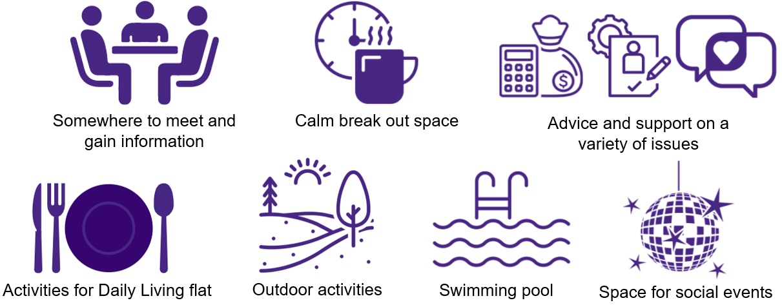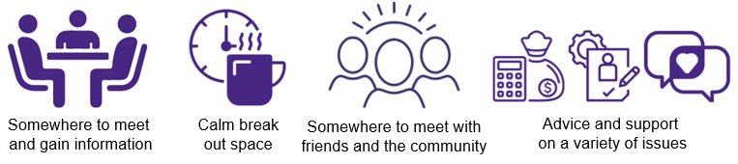

**Figure 5: Summary of the key priorities young people would like to see in a Transition Hub**

In addition to the young people, the carers who were interviewed saw the requirements for a Transition Hub as follows:

* The need to fill the huge gaps in current provision at transition
* The need for young people to learn independence skills
* Workshops for carers e.g. ALN Act
* Workshops for young people in how to stay safe / recognise ‘red flags’ / PIP and how the young people might want to handle it
* Information and resources
* Accessible youth clubs for young people up to 25 years
* A community space which facilitates peer group interface and integration
* A place to meet and make friends

Additional in-depth interviews were carried out with carers of young people with complex needs on the need for a Transition Hub.

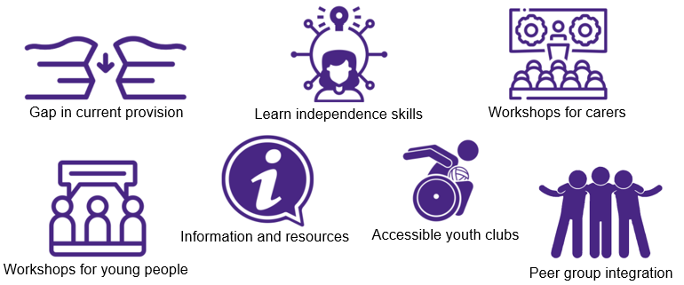

**Figure 6: Key priorities for carers that emerged out of consultations**

Findings from the consultations undertaken to support the report ‘Defining the optimal model of transition from child to adult provision’[31] have also been taken into consideration. The primary needs of families and young people identifed from these consultations are as follows:

* Person centred approaches – allowing young people to take part in decision making
* Shared responsibility for transition across child and adult services
* Better visibility of adult serivces
* Formal and informal support networks
* Enhanced relationships between agencies - including co-location and multi-agency working

# **3.3.2 Professionals**

The following is a summary of what *health* professionals felt were the priorities when it came to a Transition Hub:

* For the health service to begin to meet the requirements of the ALN Act
* Shared clinics with adult health providers e.g. physio, adult LD, physiotherapy
* Develop adolescent services and transition clinics across a range of services
* Align already existing transition services with a new Transition Hub e.g. physiotherapy
* Develop an outward looking community interface for support services in transition
* A Transition Hub that is designed by and for young people to meet their specific needs
* Focus transition services around the Malcomess approach

**Figure 7: Services and facilities suggested by professionals during consultation:**

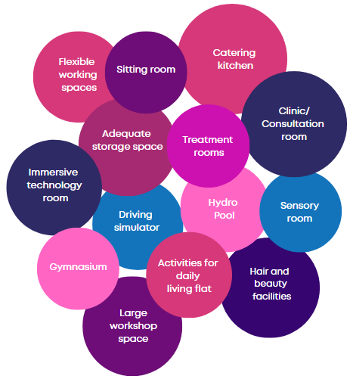

This section of the report has addressed the consultations carried out with stakeholders regarding what services and facilities they would like to see provided in a Transition Hub in North Gwent. It has laid out the requirements for a Transition Hub prioritised by young people, parents, carers and professionals.

# **3.4 Sparkle research**

Research commissioned by Sparkle in 2019 called ‘Defining the Optimum Model for Transition from Child to Adult Provision’ highlights that in Gwent:

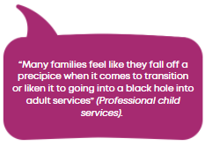

This report on transition states that ‘despite a plethora of national and regional guidance, academic publications and charity resources across the UK, young people with disability or developmental delay and their families are consistently reported in publications to have poor experiences of transition with many feeling worried, confused and unsupported in the journey to adulthood’.

It is being proposed that the new Children’s Centre in the north incorporates a Transition Hub which would support closer collaboration between health and social care agencies, and with voluntary organisations in North Gwent, to develop and deliver programmes to assist young people with disabilities and developmental difficulties with transition into adulthood and adult services. By operating together from a single site, resources and services can maximise efficiency and minimise duplication of services for this area.

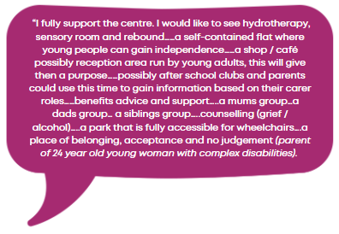The Transition Hub would work in collaboration with local colleges and local employers to ensure that young people have the skills they need to transition into adulthood and achieve greater independence.  Currently each local authority is running local transition projects but there is not enough shared learning across the greater Gwent. By developing a dedicated hub, and working in collaboration with the research team in Sparkle, projects could be evaluated, learning disseminated and more effective models of collaborative working shared and implemented across all local authority areas in Gwent. This presents an opportunity for Gwent to become a leader in the field of transition service delivery, creating a model that would be a first in Wales and from which transition services across the UK could learn.  Sparkle has already invested in a 12-month research project which would underpin the development of a comprehensive transition model.[32]

The proposal for a Transition Hub, to cater for young people from 14 to 25 years has been developed following extensive research undertaken by Sparkle in 2018 and published in 2019.  In conducting the report, interviews and focus groups with professionals, young people with complex needs who were in the planning stages of transition, and parents and caregivers of young people with complex needs. The proposed Transition Hub would be a first in Wales and would begin to address the gaps in transition services highlighted by young people and their families. The report findings highlight the main gaps in current transition as follows:

* A lack of communication between professionals and families around the details of the transition process
* A lack of a specific named person within adult services to contact in order to address issues and concerns
* A discrepancy in the eligibility criteria for access to services between child and adult services
* The assessment for adult service services are weighted towards a health focus
* Adult health services not being available until the young person has turned 18, leading to a long gap in service provision
* Difficulties in engaging with adult learning disability services and poor communication between child and adolescent mental health services and adult learning disability services
* A lack of clarity as to the eligibility for adult services
* During transition, young people and their families must reach a point of crisis before getting support
* Young people who have multiple complex needs often have a smoother and more effective transition than those without
* Learning disability services are focussed on young people with autism spectrum disorder rather than learning disabilities as a whole

In the North Gwent consultation report carried out by Sparkle in February 2021[33] looking into the need for a new Transition Hub, families and professionals stated that they wanted a Transition Hub to offer the following:

* support to develop independent living skills
* cooking and healthy living classes
* personal hygiene support
* support navigating everyday life
* peer mentoring
* sexual health information delivered through workshops
* support and information around hate crimes and domestic abuse
* financial information
* support in money management

In response to these gaps in transition identified during consultations, the report proposed an optimal model for transition, where young people between the ages of 14 to 25 would be supported in a dedicated ‘hub’ by a team of specialist transition workers alongside health, social service and voluntary sector workers. Young people would be supported by integrated transition plans, in a centre that was person-centred with unified standards.

# **3.5 The Transition Hub**

The development of a Transition Hub situated on the same site as the new Children’s Centre for the North Gwent catchment area is in line with aims of all local authority statutory agencies who are supportive of the development of more collaborative working across health and social care for young people aged 14-25 years. Learning from this centre would inform services across all areas of Gwent. This has been reinforced by consultation with young people and their carers in North Gwent.

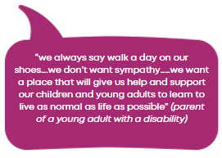The **ICF Discretionary Capital Funding 2021-22 Feasibility Project Proposal** clearly outlines a vison for the Transition Hub in respect of pathways to further education or employment for young people with disabilities or developmental difficulties, the potential for collaboration with voluntary sector organisations and local employers who would use the facilities to develop pathways to work for this client group, the potential for the hub to provide a resource for training young people in vital life skills such as travel training, staying safe etc. which adults with complex needs must acquire if they are to live fulfilling and rewarding lives as independently as possible.

*“Currently these facilities are dotted around the county, inaccessible for many families, thus leading to greater dependence on residential provision and other private service providers, which is what ICF is trying to avoid”[34].*

There is no definitive information on the number of young people in Gwent who would be eligible to access a new Transition Hub. The number of young people currently at transition age (14 to 18 year olds) who were referred via ISCAN between 2019 and 2021 was 598. Whilst not all young people referred via ISCAN will require support from the Transition Hub, this number does not include those who were referred before 2019 that will require transition support when they reach transition age, or those not referred via ISCAN. Thus, extrapolating this number to cover the ten year transition period (14-25) would suggest a minimum of 1495 young people eligible to access a Transition Hub (10x598/4). This would seem to be the minimum number in Gwent. To account for growth in numbers, the same percentage increase as applied to the number of children accessing services has been applied to the number of young people, which would give a minimum number of 3080 young people (see Appendix 4).

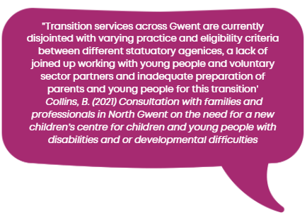Professionals and families have also stated that there is a need for better opportunities for young people to gain access to further education, work experience, sports and engaging activities and life experiences.  Partnership working with employment services, including Careers Wales and local businesses, further education and training providers such as Coleg Gwent, voluntary organisations such as Barnardo’s, Building Bridges and Mind, and local leisure services was recommended. A full summary of the transition services that families and professionals who took part in the focus groups and interviews would like to see delivered from a Transition Hub is contained within the consultation report.

# **3.6 Conclusion**

This section of the study has looked at the need for an integrated Transition Hub to serve the North Gwent catchment area with local services, and to provide an emerging model of improved collaboration between health, social care and voluntary services up to the age of 25 years, which could then inform services in other parts of Gwent. The conclusion is;

* Gwent is not fully compliant with the legislation and guidance in respect of the need for effective transition services for young people with disabilities and or developmental difficulties transiting from children to adult services
* Referenced research and consultation commissioned by Sparkle highlights an on-going struggle by Gwent statutory agencies to meet need, resulting in young people and their families feeling confused and unsupported in the young person’s journey to adulthood
* There is a need for a Transition Hub that would begin to address gaps and inconsistencies in the current system, a provision that would be a first in Wales, addressing gaps in service highlighted by Welsh Government.
* There are growing numbers of young people who are eligible to access the support services offered by a Transition Hub
* Many of the partner agencies are already signed up to the idea of a Hub which would complement existing service provision and address critical gaps
* Collaboration of interested parties would be greatly improved with a North-based integrated Transition Hub that developed an all-Gwent model of collaboration. If this model is effective in Blaenau Gwent, with high deprivation indices, and a paucity of specialist facilities, it would provide an excellent blueprint to be rolled out across Wales

# **4. PHASE 1, Section 4: Scope of design**

# **4.1 Introduction**

This section of phase 1 of the feasibility study follows on from the previous sections dealing with the need, relevant legislation, guidance and detailed consultations. It takes account of this work together with the lessons learnt from the Serennu building since opening in April 2011 in order to form a view on the requirements for the building and outdoor areas of an integrated children’s centre and Transition Hub in North Gwent. From this work a schedule of rooms and outdoor requirements by each section of the building and outside area has been compiled. Finally, this schedule has, with the help of an architect, been converted into an optimal concept design for the building and grounds.

**The key elements dealt with in this section are as follows:**

* Research and consultation
* Matters taken into account in designing room layout
* The number of people attending the Children’s Centre and the Transition Hub
* The elements of the building
* Detailed requirements for each section including size and location
* Lessons learned from the Serennu building layout, design and operation
* Other matters
* Architects concept drawing

# **4.2 Research and consultation**

The building and ground size has been based on the number of people expected to attend the centre (see previous sections) together with the services that are required in the centre. Cost has been minimised by ensuring that whilst children and young people (CYP) areas have been kept separate, services needed by both can be shared rather than duplicated. The information for this scope of design has been gathered from;

* Detailed consultations with all the interested parties
* The 2021 consultation report carried out by Sparkle on the need for a new centre in North Gwent [35]
* Research on numbers carried out by the Sparkle – “Estimated Numbers for a New Children’s Centre in North Gwent” (See Appendix 4)
* A review of the layout and operations of the Serennu building
* Visits to other CYP centres and places of interest around the UK and interviews with their management teams
* Detailed discussions with an architect on the building layout given its requirements and use

**Figure 8: Organisations consulted on the requirements for a new children’s centre and Transition Hub:**

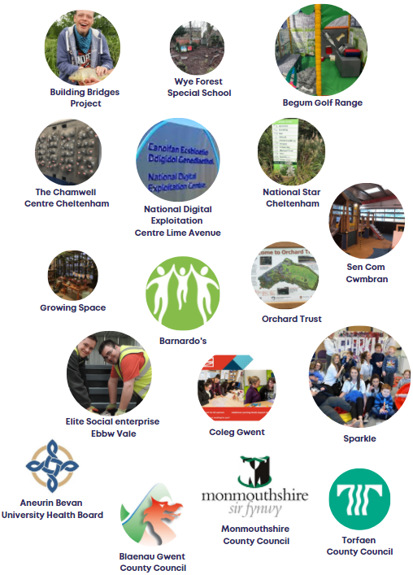

# **4.3 Room layout**

**Matters taken into account in designing the layout of rooms:**

* The need to ensure children are secure from other users and visitors
* Appropriate room sizes based on the interviews and knowledge of the functionality of the Serennu building
* Rooms to have sufficient storage facilities for their particular function to ensure efficient utilisation of professional staff, including less preparation and put away time.
* Room heights to be suitable for the room usage e.g. the Gym, reception, rebound and climbing
* All facilities used by CYP to be on the ground floor to minimise stress and access difficulties
* Easy access to the outside areas from the building
* Care to ensure rooms that are used together are close together e.g., plastering room close to the gym and therapy rooms
* Where possible rooms to be multi-functional to minimise overall space e.g., workshop to be useable as a clinic
* The gardens and outside areas (patio’s) to take account of the building location in terms of its position regarding sunlight
* The facility to have sufficient car parking space and/or be close to free car parking (preferably undercover) to minimise parental stress
* A separate and secure area for the office and meeting room users
* Allowance for hot desking, confidential pods and adjustable size meeting rooms to ensure the office space is as flexible as possible
* Easy drop off and pick up points in a covered area to assist parents in inclement weather and reduce stress
* A level site to
  + Avoid difficulties in access for CYP, staff and members of the public with physical disability
  + Minimise construction cost and future maintenance

# **4.4 Number of people attending the new North Centre**

The people attending the new centre can be split down into the following categories;

* CYP with disabilities attending clinics, therapies and leisure activities
* Parents/carers of the CYP attending the centre to support CYP or access direct services
* Individuals working at the centre including;
  + Health, local authorities and voluntary sector staff working full and part time at the centre
  + Sparkle leisure activities supervisors and play workers
  + Volunteers
  + Visitors attending for meetings/training - ABUHB, local authorities, voluntary sector organisations
  + Site administration and management

# **4.4.1 Numbers of children and young people and other users**

A report on the best estimate of the numbers in this category has been prepared and can be found at Appendix 4. The assumptions made and the data sources used in the preparation of this report are of relevance. The evaluation of the growth in numbers of users is critical as this has a direct impact on the number of clinic rooms planned for the centre and sizes of other facilities. The below table sets out the estimated numbers of users.

**Table 10: Estimated number of children and young people to attend the children centre and Transition Hub based on relaxed boundaries**

|  |  |  |
| --- | --- | --- |
|  | Currently | 2030 |
| Children’s centre | 496 | 1,022 |
| Transition Hub | 1495 | 3080 |

Research into the centre includes detailed figures of staff who will use the building, including the organisation, and if they are full or part time.

A summary table is presented below:

**Table 11: Number of staff who will work at the new centre by service**

|  |  |  |
| --- | --- | --- |
| **Service** | Number of staff | |
| Permanent | Part time/ temporary |
| Physiotherapy | 9 | 2 |
| Paediatrics | 5 | 2 |
| Speech and Language Therapy | 5 | 3 |
| Health Visitors/Flying Start | 0 | 2 |
| Dietetics | 6 | 0 |
| Community Children's Nursing | 4 | 0 |
| Portage | 2 | 0 |
| IPBS (no service yet) |  |  |
| Helping Hands | 2 | 0 |
| Occupational Therapy | 6 | 0 |
| S-CAMHS | 5 | 0 |
| CALDS | 0 | 2 |
| ISCAN | 4 | 0 |
| Centre Admin | 3 | 0 |
| Sparkle | 60 | 1 |
| CET Neurodevelopmental (ND) | 0 | 2 |
| Audiology | 1 | 0 |
| PCMHSS | 0 | 3 |
| Public Health Nursing | 0 | 1 |
| Bridges | 0 | 2 |
| Blaenau Gwent Disability Team | 4 | 2 |
| Disability Sports Officers | 1 | 0 |
| Children's Disability Team Torfaen | 1 | 0 |
| Orthotics | 1 | 0 |
| Blaenau Gwent Education | 1 | 0 |
| Volunteers | 20 | 0 |
| Growing Space | 2 | 6 |
|  | 64 | 22 |

# **4.5 The main elements of the building**

It is considered there are seven key elements to the building and outdoor area as follows;

* The welcome/reception area
* The Children’s Centre
* The Transition Hub
* Offices and meeting rooms for staff and visitors
* Shared facilities
* Gardens, learning, play and horticulture areas
* Parking

The consultation exercise detailed in sections ‘2.3’, ‘2.5.1’ and ‘3.3’ of this report provided an enormous amount of detail which has been the basis for informing the building requirements for the new centre.

The detailed requirements for each of the seven elements of the site derived from consultation and research are discussed below.

# **4.6 The welcome/reception area**

Key to the centre will be a reception which is easily accessible and welcoming. The plans include a large wind and water proofed canopy area where cars/mini buses can stop to drop off the centre users together with double doors to access the centre.

Comments on the reception area include that it should be designed to be open and welcoming without being too distracting for CYP who are there to attend clinic and other appointments. There will be a small room within reception to give easy access to the Family Liaison Officer who will be visible.

Other elements requested for reception is a low-level reception desk together with sign in pods.

Leading off from the reception is;

* The Transition Hub (secure)
* The Children’s Centre (secure)
* The coffee and snack shop with an arts and crafts shop

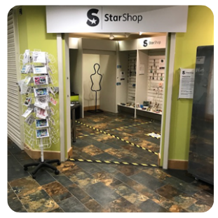**The coffee and snack shop with an arts and crafts shop (58m2)**

**National Star shop in Cheltenham**

This area is separated from the reception area but accessible. The separation will help remove distractions from the users and be a space for parents to wait for their CYP if they need to. The coffee shop will have an accessible counter from the Transition Hub with general public access from the reception parts of the building. In addition, part of the room will have space for a small walk-in display area for viewing and buying products made by CYP. There is potential to use/sell or give away produce grown in the horticulture area in the coffee shop. The centre plan also allows for a central courtyard accessible from the coffee shop for use when weather allows. This will give further space for outdoor activities.

**An arts and crafts shop**

* Exhibiting and selling products made by CYP using the centre
* Situated in the coffee shop area

# **4.7 The Children’s Centre**

From all the consultation and research carried out detailed tables of requirements, in respect of each interested party has been produced as follows:

* Appendix 6 - the requirements for the Children’s Centre
* Appendix 7 - the requirements for the Transition Hub
* Appendix 8 - room specifications for all rooms at the new centre

Room sizes are based on those at the integrated Serennu Children’s Centre with adjustments made to incorporate comments and suggestions received from the consultation and suggestions process to account for under, oversized or surplus to requirement rooms (see lessons learned: Appendix 9). CCTV facilities would be in place in key rooms for observations, replacing the need for two-way mirror observation rooms. Dimensions of rooms at the integrated Serennu Children’s Centre are included in this table together with other relevant information.

Room layout in the new centre is based on all user rooms being on the ground floor. This removes the need for stairs and lifts for users which for people with disability can cause problems and stress. The offices and associated meeting rooms are located on the first floor.

**Further specification – room layout**

**Waiting rooms (Therapies 80m2 and Clinics 100m2)**

The plans include two waiting rooms. One is for clinic appointments and the other for therapy appointments and leisure clubs. Both are appropriately situated close to the area they serve. The therapies waiting area is similar to Serennu and the clinics waiting area somewhat smaller (100 compared to 140m2).

**Clinic rooms (21m2 each plus one at 25m2 to allow division)**

Around the clinic waiting room it is planned to have 5 clinic rooms. One to have a soundproof divider to allow it to be split into two rooms for additional clinic space. Room sizes are based on Serennu.

**Nurses station (16m2)**

This is located in the clinical area adjacent to a weighing room with double access from the nurse’s station and waiting area. This room is 3m2 bigger than the nurse’s station at Serennu due to feedback that this room is not big enough.

**Therapy rooms (80, 53, 30m2)**

There are three therapy rooms. They are of different sizes and all are linked by soundproof movable dividing walls. This gives maximum flexibility in terms of room usage. Room sizes are based on Serennu.

**Workshop (25m2)**

The workshop used by therapy and orthotic staff is located near a clinic and plastering room. It is designed for dual use as a workshop or clinic space and is thus slightly larger than the workshop at Serennu.

**Plastering (24m2)**

The plastering room is designed for dual use in terms of plastering and alternative clinic space. It is located close to the therapy rooms, gym and soft play to enable ease of access for therapy and other staff. The room is 4m2 bigger than the plastering room at Serennu to allow for dual use.

**Clinic room for therapies (16m2)**

This is adjacent to the plastering room and will be dual use. The room is bigger than the clinic room for therapies at Serennu due to feedback that the room wasn’t big enough.

**Soft play (40m2)**

This room is located by the therapy rooms and is significantly bigger than the soft play room at Serennu (20m2) due to comments regarding accessibility for children in wheelchairs.

**Family, activities of daily living (ADL) and kitchen rooms (54m2)**

These rooms are located together and are the equivalent of the ADL flat at Serennu. At Serennu the bathroom and bedroom in the flat are not used and following consultation it has been concluded they are not required in the new centre. The kitchen is designed with dual access from the corridor and ADL room. The ADL room is designed to double up as a meeting space.

**Sensory (30m2)**

This room is bigger than the sensory room at Serennu (30m2 compared to 24m2) to facilitate access to children who are in wheelchairs. The room is located close to the therapy rooms as this facility may be used as part of a child’s treatment.

**Messy play (21m2)**

The room at 21m2 is slightly larger than the room at Serennu which is 18m2. It is located close to sensory and therapy rooms.

**Audiology (16m2)**

The room is situated within the clinic area. This is a specialist room with a high cost of construction. The need for an adjacent room and a one-way glass panel for observation is removed by the inclusion of CCTV. The CYP can be observed from any confidential space in the building.

**Storage**

All the rooms in the Children’s Centre have been designed to have adequate storage space in close proximity. In nearly all cases the storage space is accessible from the corridor and therapy rooms.

# **4.8 The Transition Hub**

This part of the building is devoted to CYP with complex needs in the age range 14 to 25. Entry to the Transition Hub will be through secure doors and will be restricted to attendances for pre booked:

* Clinics
* Learning/educational sessions (young people, parents and carers)
* Social and activity clubs

This would be the first fully integrated Transition Hub in Wales. After considerable research and consultation with professionals, parents and young people we have concluded that for this facility to produce good outcomes for young people it will be developed as a collaboration venture between interested parties from statutory and voluntary sectors (See guidance: National Service Framework for Children, Young People and Maternity Services (2004)[36].

From the detailed research and consultations carried out, the Hub has been configured as follows;

* A central social and leisure area with access to the coffee and food/snack shop
* Tech Hub
* Learning area opening out to a patio, gardens and horticulture activities
* Chill room/quiet space
* Clinic rooms (2)
* Separate access to the gym, rebound and hydrotherapy rooms
* Additional access to a patio and the gardens including the horticulture building and growing area
* An art and craft shop exhibiting and selling products made by the young adults and children using the centre (situated in the coffee shop area)

**Further specifications – room layout**

**The social area (160m2)**

The social area will have direct access to the coffee and snack shop, areas for interactive games, group socialising, soft play and chilling. It is expected that young people with complex needs will also be working in the social area of the Hub and coffee shop either as employees, trainees or volunteers.

**Tech Hub (40m2)**

This room is planned to house IT including computers, printers, video, film and interactive technology will be available for informal and formal learning. During our research we discussed the facilities with both “Tech Valleys” and “National Digital Exploitation Centre.” Positive responses and guidance was given to assist with this facility and tech learning.

**Learning area opening out to a patio, the gardens and horticulture activities (114m2)**

This is a suite of rooms including a large flexible learning/meeting room, connected kitchen and small learning/meeting room and the appropriate storage facilities. There is a flexible partition in the large meeting room to divide into two if required to give additional space for clubs and learning and meetings by professionals (e.g. supervised contact).

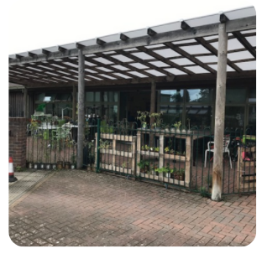This suite of rooms will have the benefit of opening out to a patio area where learning can take place outside when weather permits. This facility was repeatedly mentioned in consultations with interested groups.

**Patio area at Star College Cheltenham**

**Chill room/Quiet room (25m2)**

This room is dual purpose. Firstly, to accommodate young people who need some quiet time to themselves, and secondly to enable meetings and some clinics to be held in more relaxed surroundings.

**Clinic rooms (21m2 each)**

The Transition Hub will have two clinic rooms. Within the social area there will be a partitioned off waiting area for families. The clinics will cater for the 14 -25-year age group and ensure a seamless transition in their clinical care to early adulthood. This should lead to the following benefits: better attendances, better knowledge of the individual, a calmer environment for young people, and more continuity, with young people attending a place they are familiar with through to 25.

**Separate access to the Gym, Rebound and Hydrotherapy rooms**

From the Transition Hub there is direct secure access to the gym, rebound and hydrotherapy rooms. This will enable this cohort of young people to benefit from shared facilities for activity clubs and therapy whilst maintaining the security of the younger children through time-tabling.

# **4.9 Offices and meeting rooms**

The design of office accommodation at the centre has taken note of the views of professionals. Over the last two years there has been a great deal of change in how people work with more flexible working taking place. It is not known how in the long-term current working practices will evolve but it is not expected they will go back to pre-covid times. For this reason, the office space has been left as open plan with the ability to create sound proof team areas. There are facilities for confidential meetings in soundproof pods and a range of different sized meeting rooms capable of opening out or being sub-divided. There is an area for hot desks. Staff facilities including a canteen and rest area have been included.

Included on this floor are rooms for the caretaker, cleaners, plant and server rooms. All are of similar size to those at Serennu.

# **4.10 Shared facilities**

Key facilities beneficial to both the young adults and children will include, indoors: the hydrotherapy, gym and rebound/climbing wall. Outdoors: the various gardens and horticulture areas. However due to safeguarding guidelines it is necessary to ensure that secure separation of some of these facilities can be achieved. This has been managed by creating separate access through a secure access system. The indoor shared facilities are in a separate designated area, close to the Transition Hub and the Children’s Centre. Outdoors the shared facilities are accessible from both the Transition Hub and the Children’s Centre.

# **4.11 Gardens, learning, play and horticulture areas**

The outdoor area is of sufficient size to include the key facilities requested during our consultation and research work. These include;

* Horticulture
* Sensory garden
* Messy/woodland area
* Learning area’s e.g. road safety
* Play ground

If the site cannot share leisure centre facilities locally then in addition to the above there will be a need for;

* Outdoor all-weather pitches
* Multi-use games area (MUGA)

**Horticulture**

As mentioned above Growing Space are one of the collaborators for the new centre. They are experts in the field of horticulture for people with disabilities. We have discussed with them appropriate facilities and layout. At this feasibility stage the outline for the horticulture area is:

* 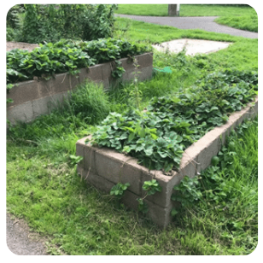An outbuilding to accommodate a learning and growing area, toilets, boot room and staff, volunteers and user’s room. Within the learning room space for activities such as making bird boxes etc.
* An outside small patio attached to the horticulture building for learning activities weather permitting
* Poly tunnels for growing produce
* Raised flower and produce beds
* Areas for reflection, relaxation or chilling

**Raised produce beds at Orchard Trust**

**Additional access to a patio and the gardens including the horticulture building and area**

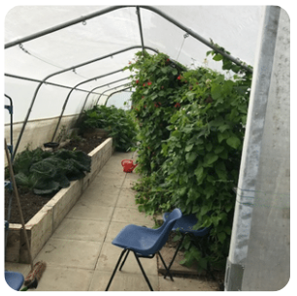The patio and garden areas will be well situated to benefit from the sun. From the Transition Hub there will be direct access to a range of gardens and the horticulture building. During our research we have received many comments and requests for horticultural activities for CYP. This has included basic gardening, seeding, potting and growing for a range of vegetables, flowers etc. In Ebbw Vale there is a tree plantation project by ‘Growing Space’ which with suitable location will enhance and add to the available horticultural activities at the centre. Horticulture plans have been drawn up after consultation with ‘Growing Space’. Growing Space have their own staff and volunteers many of whom have a disability.

**Poly tunnel at Orchard Trust**

**Sensory garden**

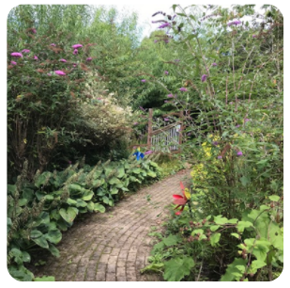Sensory gardens can give great solace and benefit in times of stress for CYP and their families. They are also a place where staff can relax during their work breaks.

**Sensory garden at Orchard Trust**

**Messy woodland area**

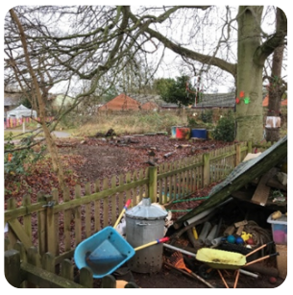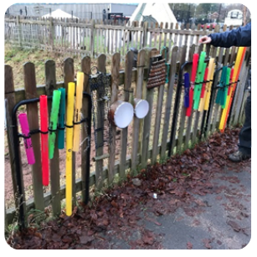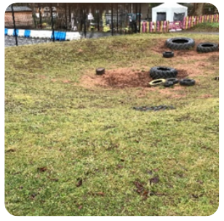This area is beneficial to both young adults and children. It is an activity and learning area in one.

**Woodland play and activity area Wyre Forest special school**

**Learning areas**

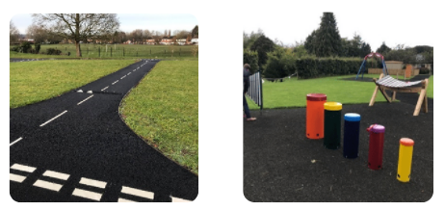This outdoor area will be taken up with activity, learning and sensory areas. Examples of these are below;

**Road safety at Wyre Forest Sounds stimulation at National Star**

**Playground area**

A playground offering disability play equipment is planned but if the site is close to a leisure centre offering this facility the range of equipment may be curtailed and costs saved.

# **4.12 Parking**

For any new build the potential area taken up by parking can be considerable and costly.

For comparison, Serennu Children’s Centre have 58 standard parking spaces, 10 disabled parking spaces and 13 children and family parking spaces, with a total of 81 spaces. However, these numbers are insufficient, as the car park at Serennu is consistently full. Therefore, a new centre would need a larger number of parking spaces.

It is noted that if a site could be located with a nearby free covered parking facility with a covered weather proofed walkway, this would reduce considerable stress to users and their parents in addition to the construction and land cost by reducing the building requirements and site area.

The preferred site would then only require parking for pick up and drop off and those with mobility issues.

# **4.13 Lessons learned**

As part of the consultation process, staff at Serennu were asked to review aspects of the Serennu building that did not work or that could have been done better. This led to the creation of a detailed table of ‘lessons learned’ from the integrated Serennu Children’s Centre (Appendix 9). This work was integral to the evaluation of room sizes, location and requirements.

# **4.14 Architect’s plans**

From the detailed room and facilities requirements above, a concept design has been prepared. This is laid out below.

**Outdoor area**

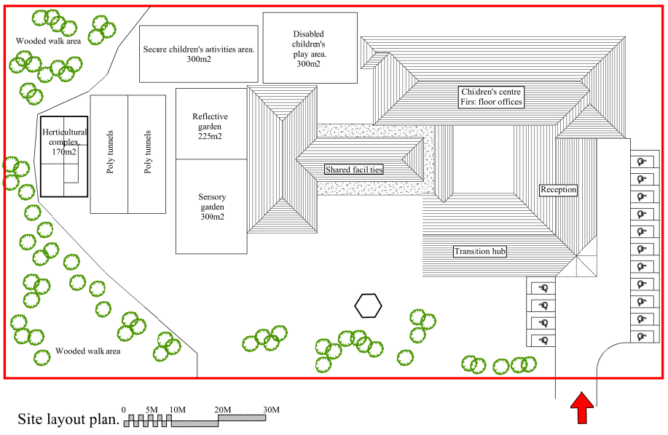

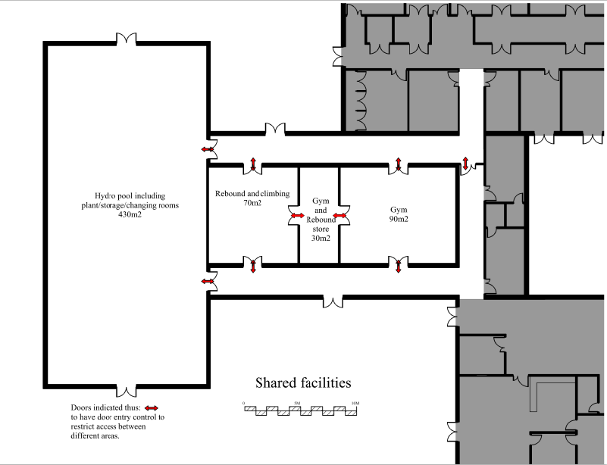**Ground Floor**

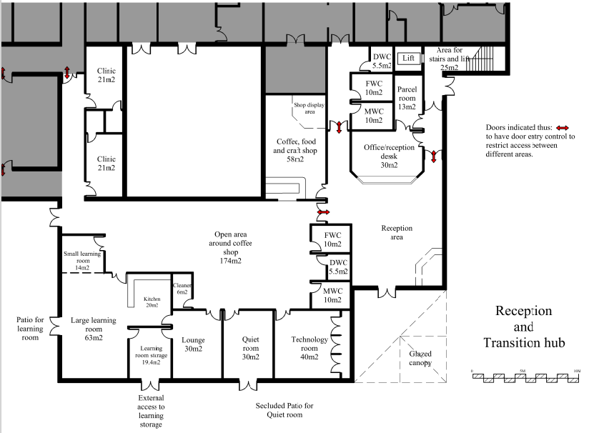

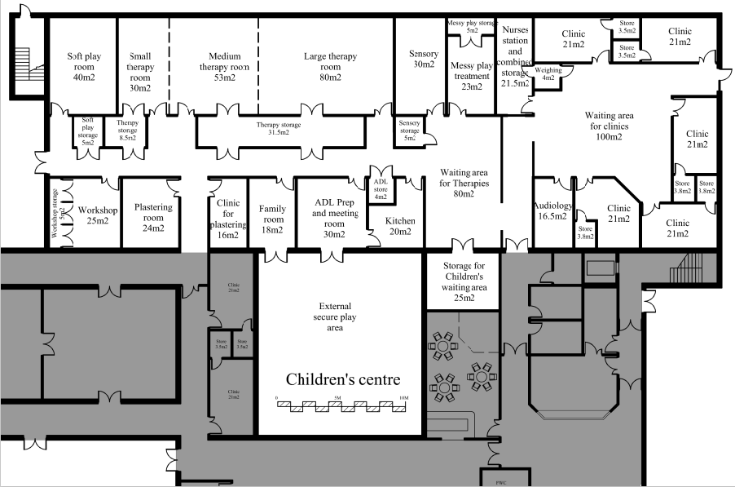

**First Floor**

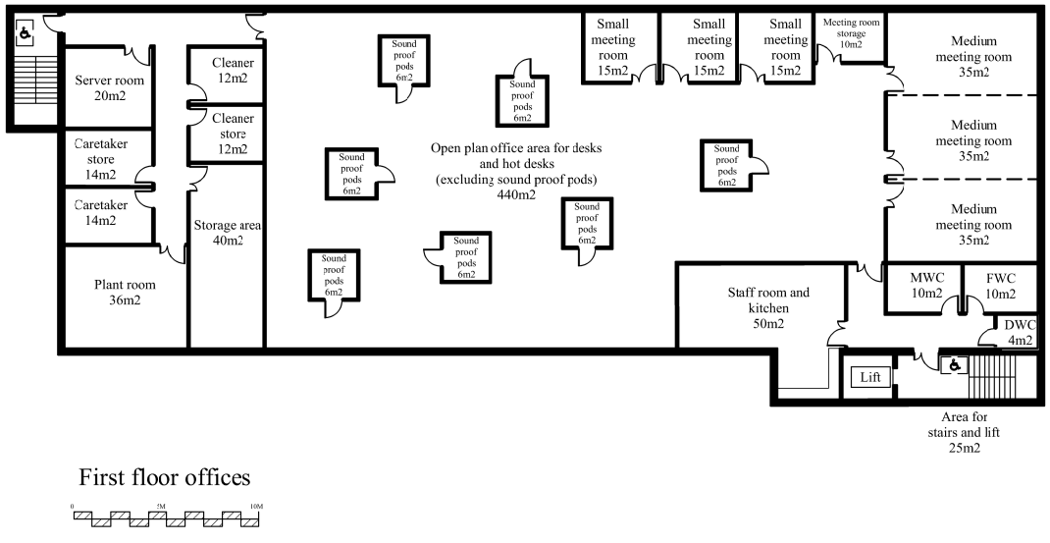

# **4.15 Conclusion**

From the detailed room and facilities requirements, a concept design has been prepared. The building areas where clinics, therapies, learning and activities will take place are all on the ground floor for easy access. Offices and meeting rooms for staff are on the first floor in a secure area with appropriate facilities to account for new agile working and confidentiality. The area’s shared by both children and young adults are located on a separate wing which is accessed by secure access-controlled corridors from the Children’s Centre and Transition Hub. The Transition Hub is part of the building but has a separate entrance so has its own independent setting. There is plentiful access to the outdoor activity and garden areas. The entire site is secure. All lessons learned from the Serennu building have been accounted for in the design. We estimate a site of approximately 3.5 acres is required. This will be somewhat larger if considerable on-site parking is required, and smaller if not. Nearby facilities such as sports and leisure would reduce the site size further. The building footprint is estimated at 3,600m2.

# **Appendices**

# **Appendix 1 – Who are Sparkle?**



# **Appendix 2 - Case Studies: Nevill Hall Children’s Centre**



# **Appendix 3 - Letters of support from families of children and young people with disabilities**



# **Appendix 4 - Estimated numbers for the new Children’s Centre and Transition Hub**



# **Appendix 5 - ICF Feasibility Proposal**



# **Appendix 6 - Building requirements for the new Children’s Centre by service**



# **Appendix 7 - Building requirements for the Transition Hub by service**



# **Appendix 8 - Rooms at the new centre**



# **Appendix 9 - Lessons learned from Serennu Children’s Centre**



# **Appendix 10 - Consultation questionnaire**



1. UK Government (2014) *Social Services and Well-being (Wales) Act 2014*.

   Available at: [Social Services and Well-being (Wales) Act 2014 (legislation.gov.uk)](https://www.legislation.gov.uk/anaw/2014/4/section/21)
2. Welsh Government (2018) *Learning Disability Improving Lives Programme.*

   Available at: [learning-disability-improving-lives-programme-june-2018.pdf (gov.wales)](https://gov.wales/sites/default/files/publications/2019-03/learning-disability-improving-lives-programme-june-2018.pdf)
3. Welsh Government (2021) *The Additional Learning Needs Code for Wales 2021*.

   Available at: [210326-the-additional-learning-needs-code-for-wales-2021.pdf (gov.wales)](https://gov.wales/sites/default/files/publications/2021-03/210326-the-additional-learning-needs-code-for-wales-2021.pdf)
4. Welsh Parliament Equality and Social Justice Committee (2022) *Minding the future: The childcare barrier facing working parents*. pp.38

   Available at: https://business.senedd.wales/documents/s122062/Report.pdf
5. National Service Framework for Children, Young People and Maternity Services (2004) *Disabled Children and Young People and those with Complex Health Needs*.

   Available at: [08 Disabled Child.qxd (publishing.service.gov.uk)](https://assets.publishing.service.gov.uk/government/uploads/system/uploads/attachment_data/file/199955/National_Service_Framework_for_Children_Young_People_and_Maternity_Services_-_Disabled_Children_and_Young_People_and_those_with_Complex_Health_Needs.pdf)
6. Gwent Regional Partnership Board. (2022) *Population Need Assessment.*
7. NICE (2018) *Learning disabilities and behaviour that challenges: service design and delivery*. Available at: [Learning disabilities and behaviour that challenges: service design and delivery (nice.org.uk)](https://www.nice.org.uk/guidance/ng93/resources/learning-disabilities-and-behaviour-that-challenges-service-design-and-delivery-pdf-1837753480645)
8. Children’s Commissioner for Wales (2020) *No Wrong Door: brining services together to meet children’s needs*. Available at: [NoWrongDoor_FINAL_EN230620.pdf (childcomwales.org.uk)](https://www.childcomwales.org.uk/wp-content/uploads/2020/06/NoWrongDoor_FINAL_EN230620.pdf)
9. The Well-being of the Future Generations Commissioner for Wales (2020) *The Future Generations Report 2020.* pp. 335. Available at: [FGC-Report-English.pdf (futuregenerations.wales)](https://www.futuregenerations.wales/wp-content/uploads/2020/05/FGC-Report-English.pdf)
10.
11. Elliott, F. & Maguire, S. (2019) *Research and Development Project: The views of parents and professionals on specialist provisions for children with disabilities and their families in North Gwent.*

    Available at: [Findings from the research in North Gwent_27_11_19.pdf (sparkleappeal.org)](https://www.sparkleappeal.org/ckfinder/userfiles/files/Findings%20from%20the%20research%20in%20North%20Gwent_27_11_19.pdf)
12. Collins, B. (2021) *Consultation with families and professionals in North Gwent on the need for a new children’s centre for children and young people with disabilities and or developmental difficulties.* Sparkle Appeal.
13. See Appendix 4
14. Houtrow, A.J., Larson, K., Olson, L.M., Newacheck, P.W., & Halfon, N. (2014). Changing trends of childhood disability, 2001-2011. *Paediatrics*. 134(3), pp. 530-538.
15. Welsh Government (2021) *Children receiving care and support by local authority and disability.* Available at: [Children receiving care and support by local authority and category of need (gov.wales)](https://statswales.gov.wales/Catalogue/Health-and-Social-Care/Social-Services/Childrens-Services/children-receiving-care-and-support/childrenreceivingcareandsupport-by-localauthority-categoryofneed)
16. Postcode Area. Available at: [Postcode Area - comprehensive local information for all UK postcodes](https://www.postcodearea.co.uk/)
17. Collins, B. (2021) *The views of families and professionals on specialist provisions for children and young people with disabilities and/or developmental difficulties, and their families, living in Caerphilly County Borough*. Available at: [Caerphilly Report (sparkleappeal.org)](https://www.sparkleappeal.org/ckfinder/userfiles/files/Consultation%20with%20Families%20and%20Professionals%20in%20Caerphilly-compressed.pdf)
18. Collins, B. (2021) *Consultation with families and professionals in North Gwent on the need for a new children’s centre for children and young people with disabilities and or developmental difficulties.* Sparkle Appeal.
19. See Appendix 4
20. UK Government (2012) Pan-Gwent Multi-Agency Transition Protocol for Young People with Disabilities and/or Additional Learning Needs. Available at: [Layout 1 (torfaen.gov.uk)](https://www.torfaen.gov.uk/en/Related-Documents/Disabled-People/Transition-into-Adulthood/Pan-Gwent-Multi-Agency-Transition-Protocol-for-Young-People-with-Disabilities-and-Additional-Learning-Needs.pdf)
21. Aneurin Bevan University Health Board. (2021) Annual Plan. Available at: https://abuhb.nhs.wales/files/key-documents/annual-plan-2021-2022/2021-22-health-board-annual-plan-pdf/
22. National Service Framework for Children, Young People and Maternity Services (2004) *Disabled Children and Young People and those with Complex Health Needs*.

    Available at: [08 Disabled Child.qxd (publishing.service.gov.uk)](https://assets.publishing.service.gov.uk/government/uploads/system/uploads/attachment_data/file/199955/National_Service_Framework_for_Children_Young_People_and_Maternity_Services_-_Disabled_Children_and_Young_People_and_those_with_Complex_Health_Needs.pdf)
23. Welsh Government (2004) *Special Educational Needs Code of Practice for Wales.*

    Available at: [Cover & Inside cover - English (gov.wales)](https://gov.wales/sites/default/files/publications/2018-03/special-educational-needs-code-of-practice-for-wales.pdf)
24. Welsh Government (2021) *The Additional Learning Needs Code for Wales 2021*.

    Available at: [210326-the-additional-learning-needs-code-for-wales-2021.pdf (gov.wales)](https://gov.wales/sites/default/files/publications/2021-03/210326-the-additional-learning-needs-code-for-wales-2021.pdf)
25. Welsh Government (2022) *The Transition and Handover Guidance.* Available at: [The Transition and Handover Guidance_February 2022 (gov.wales)](https://gov.wales/sites/default/files/publications/2022-02/transition-handover-guidance-children-adult-services_2.pdf)
26. Gwent Regional Partnership Board (2022) *Gwent Population Needs Assessment.*
27. NICE (2018*) Learning disabilities and behaviour that challenges: service design and delivery*. Available at: [Recommendations | Learning disabilities and behaviour that challenges: service design and delivery | Guidance | NICE](https://www.nice.org.uk/guidance/ng93/chapter/Recommendations#services-in-the-community-prevention-early-intervention-and-response)
28. Children’s Commissioner for Wales (2020) *No Wrong Door: brining services together to meet children’s needs.* Available at: [NoWrongDoor_FINAL_EN230620.pdf (childcomwales.org.uk)](https://www.childcomwales.org.uk/wp-content/uploads/2020/06/NoWrongDoor_FINAL_EN230620.pdf)
29. Children’s Commissioner for Wales (2019) *‘Don’t Hold Back’ Transitions to adulthood for young people with learning disabilities*. Available at: [Dont-Hold-Back.pdf (childcomwales.org.uk)](https://www.childcomwales.org.uk/wp-content/uploads/2019/10/Dont-Hold-Back.pdf)
30. UK Government (2014) *Social Services and Well-being (Wales) Act 2014*.

    Available at: [Social Services and Well-being (Wales) Act 2014 (legislation.gov.uk)](https://www.legislation.gov.uk/anaw/2014/4/section/21)
31. Hurrell, C. (2019) *Defining the optimum model for transition from child to adult provision for young people with disabilities and or developmental difficulties in Gwent.* Available at: [Transitiom.pdf (sparkleappeal.org)](https://www.sparkleappeal.org/ckfinder/userfiles/files/Transitiom.pdf)
32. Hurrell, C. (2019) *Defining the optimum model for transition from child to adult provision for young people with disabilities and or developmental difficulties in Gwent.* Available at: [Transitiom.pdf (sparkleappeal.org)](https://www.sparkleappeal.org/ckfinder/userfiles/files/Transitiom.pdf)
33. Collins, B. (2021) *Consultation with families and professionals in North Gwent on the need for a new children’s centre for children and young people with disabilities and or developmental difficulties.* Sparkle Appeal.
34. Sparkle Ltd (2021*) ICF Discretionary Capital Funding 2021-2022 Feasibility Project Proposal.* 
35. Collins, B. (2021) *Consultation with families and professionals in North Gwent on the need for a new children’s centre for children and young people with disabilities and or developmental difficulties.* Sparkle Appeal.
36. National Service Framework for Children, Young People and Maternity Services (2004) *Disabled Children and Young People and those with Complex Health Needs*.

    Available at: [08 Disabled Child.qxd (publishing.service.gov.uk)](https://assets.publishing.service.gov.uk/government/uploads/system/uploads/attachment_data/file/199955/National_Service_Framework_for_Children_Young_People_and_Maternity_Services_-_Disabled_Children_and_Young_People_and_those_with_Complex_Health_Needs.pdf)