How to get to Serennu Children’s Centre

Address
Serennu Children’s Centre
Cwrt Camlas
High Cross
Rogerstone
Newport
NP10 9LY

Tel: 01633 748000

Opening hours
Monday to Thursday 8.30am to 5.00pm
Friday 8.30am to 4.30pm

Please note:
If you are attending clinics or recreational activities taking place in the evening or on a Saturday then please use the rear entrance of the building as no access is available at the main entrance.

By car

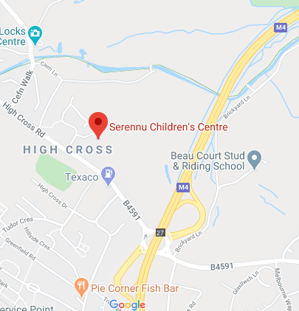
You can view directions on Google Map [Link to - https://www.google.co.uk/maps/place/Serennu+Children's+Centre/@51.5884594,-3.0405079,17z/data=!3m1!4b1!4m5!3m4!1s0x4871e1111f9afec9:0xd9b2228c37060319!8m2!3d51.5884561!4d-3.0383192?hl=en]

By bus
View the https://www.traveline.cymru/ (opens in new window) for details of how to get here by bus, train or coach.
You may be eligible for transport from the Welsh Ambulance Service Trust, please check the Ambulance transport Jan 17 leaflet.

How to get to Nevill Hall Children’s Centre

Address
Nevill Hall Children’s Centre
Nevill Hall Hospital
Brecon Road
Abergavenny
NP7 7EG
Tel: 01873 732712
Opening Hours
Monday to Thursday 9am to 5.00pm
Friday 8.30am to 4.30pm

By car

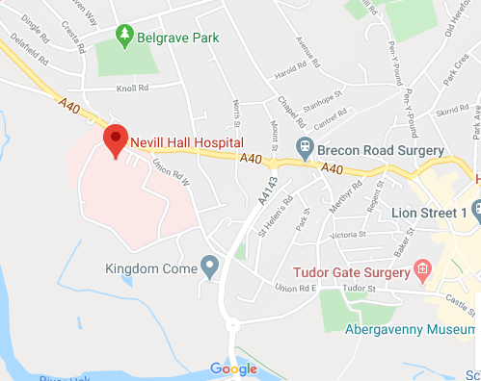

You can view directions on Google Map [Link to - https://www.google.co.uk/maps/place/Nevill+Hall+Hospital/@51.8250974,-3.0366367,17z/data=!3m1!4b1!4m5!3m4!1s0x4871d74d6724e8f1:0xb1d4b1bd7770ba91!8m2!3d51.8250941!4d-3.034448?hl=en]

By bus
View https://www.traveline.cymru/ or https://bustimes.org/stops/5330AWB32327 for details of how to get here by bus, train or coach.

