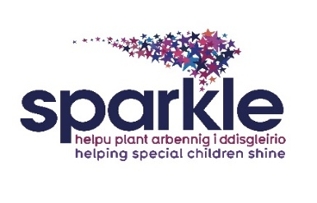

*Referral Form for Leisure Activities

Please ensure that this form is completed in full to avoid a delay in accessing the leisure services

How did you find out about Sparkle? |  | Occupational Therapy |  | Speech and Language
Family Liaison Officer | Physio |  | Paediatrics |  | Other (please specify)

Name |  | Date of Birth
Address |  | Email address
Mobile number |  | Home Number
Preferred method of contact  (you may select more than one method) |  | Post Telephone  Email

Details of Serennu based professional who will endorse this referral:
Name:
Department:
Contact details:

Alternative contact:

For Swim Lesson Referrals Only:
Did a professional recommend swimming lessons to you? Yes/No
(If yes, which service referred you)
Occupational Therapy Speech and Language Physio

Family Liaison Officer Paediatrics Other (*please specify)
Has your child ever had hydrotherapy? Yes/No
If ‘yes’ is this ongoing? Yes/No

Additional information that you feel it is important Sparkle are made aware of, relating to the child or parents needs in preparation for the profile meeting.
Contact details of referrer | Name:  Relationship to child / young person:  Contact Number:  Email:  Date referral form has been completed:

When the referral form has been received, a Sparkle member of staff will contact the family, to invite them into the centre to complete a personal profile and discuss which activities would best meet the child / young person’s needs.

Please return the completed referral forms to: Sparkle Office, Serennu, Cwrt Camlas, High Cross, Newport,NP10 9LY.
Email: ABB_SparkleActivities@wales.nhs.uk

The information you give to Sparkle is important to us. We believe the most important details are yours. We will keep the information you share with us safe and secure.
The new GDPR legislation states that we now need your consent to do so, this is called ‘opt in’. If you agree to your information being held by Sparkle, please tick the box

Date:_________
You can find more information on how we use your personal information on: www.sparkleappeal.org/blog/sparkle-privacy-policy
Office Use:

Actions | Date | Staff initials
Date referral received
Date of personal profile meeting
Date referrer has been contacted
Date ‘Referral’ spreadsheet updated

