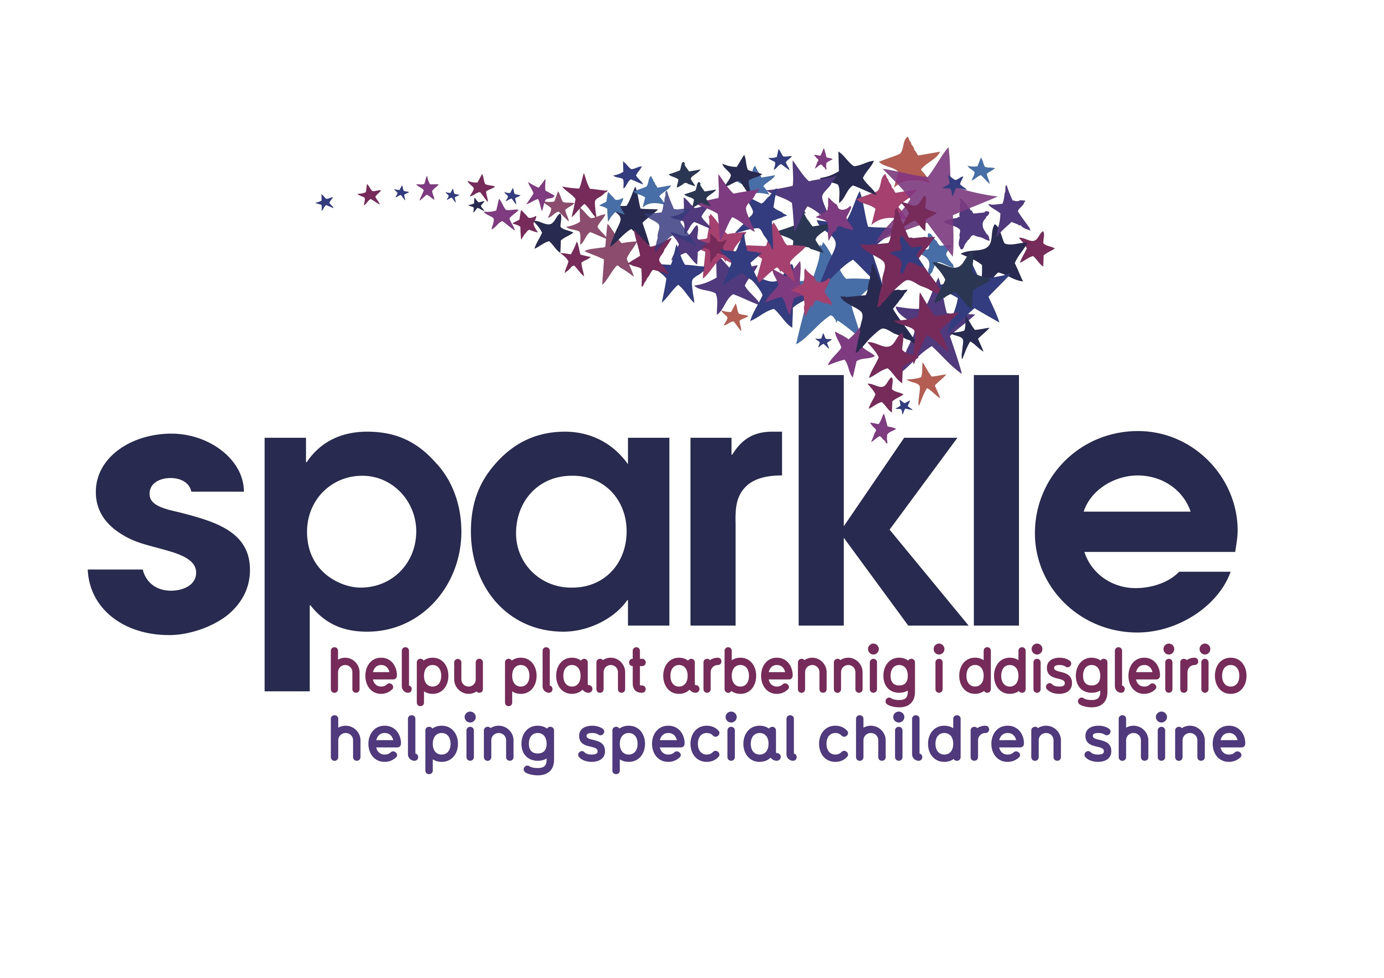
Sparkle Trustee position – Job Advertisement

Sparkle are looking for a Trustee with PR / marketing skills. Details are below and in the full Trustee Recruitment Pack.

Board Position Details
Sparkle (South Wales) Ltd
Serennu Children's Centre
Cwrt Camlas
Rogerstone
Newport
NP10 9LY

Organisation: Sparkle (South Wales) Ltd
Organisation type: Charity / NFP
Coverage: Gwent, South Wales
Position Title: Board Member
Duration of appointment: 3 years
Remuneration: expenses paid
Industry sector: children/ young people, disability, learning difficulties
Skills sought: PR/ Marketing, digital media knowledge, fundraising

Closing date: 1st May 2021

Position description
Sparkle have led the way on fully integrated services for children and young people with disability or learning difficulties, and we are now expanding our services across a wider geographic area. We are seeking a Board member who can bring passion and enthusiasm for what we do, and use their PR/ Marketing skills, digital & social media communications knowledge, to help us to raise the charity’s profile.

Our Board meetings are held monthly, and can be attended virtually.

About the organisation
We believe that every child with complex needs should reach their full potential, regardless of their disability or learning difficulties. In 2011 we opened Serennu, a unique Children’s Centre in South Gwent with an award winning design, set in it’s own landscaped grounds, with a 3D medicinema, indoor and outdoor sports facilities. Here 300 families a week access health & social care professionals, in addition to support and activities for children 0-18 years with disability, or learning difficulties. We are now expanding our services to the North and West of Gwent, and aim to provide the same standard and range of support to families there.

Sparkle is a registered charity, operating as a company limited by Guarantee.

Selection Criteria
The Trustee Board already has a diverse mix of backgrounds and experience. Together, we have detailed our Charity’s strategy and vision for the next five years, and identified that we need a Trustee to take the lead on PR/Marketing and digital communication, to help us achieve our objectives.

We would love to speak to candidates with specialist skills in any of the following sectors:

- Marketing skills and knowledge
- PR and Stakeholder Relations – knowledge that supports promoting a positive perspective about the charity/ advising on building relationships with press contacts/stakeholder communication and relationship development
- Knowledge of CMS platforms
- Digital/Social Media communications and analytics experience across various platforms in a business capacity

Website www.sparkleappeal.org

How to apply
If you are motivated to make a difference to the lives of children facing complex challenges, and see first hand the impact of your work, please contact the office for a full application pack, on enquires@sparkleappeal.org or send a CV and covering letter outlining how you would meet our Chairman, Sabine Maguire on sparklechair@gmail.com

