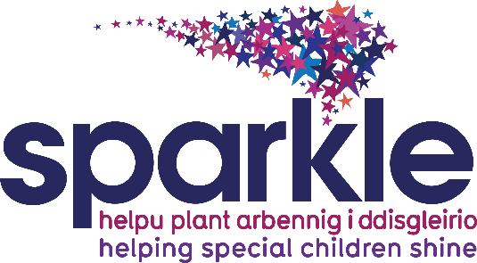

Marketing Volunteer Role Description
Role title | Marketing Volunteer
Location | Serennu Children’s Centre and the wider Gwent area
Time Commitment | Flexible on a case by case basis
The role description | To support the Sparkle Fundraising and Marketing team with a range of fundraising duties
Things you can get involved with | - Helping to raise vital funds for Sparkle by using your local knowledge to engage further support for our cause  - Planning and holding fundraising events which engage your local community e.g. coffee mornings  - Actively networking through personal connections or local opportunities  - Attending the 4 annual Sparkle fun days  - Holding bucket collections and bag packing events  - Attending community group meetings and events to enlist support from local groups  - Supporting the placement and administration of collection tins  - Distributing event posters and recruiting event participants
Skills, experiences and qualities required | - Good communication skills  - Creative, reliable and enthusiastic  - Ideally, previous experience of networking or fundraising  - Knowledge of Newport and wider South Gwent area  - Friendly, reliable, approachable and a confident team player
Support offered | - Training and induction to the role  - Individual support meetings with Supervisor (Fundraising Manager)  - On-going informal support from the Volunteer Manager, other staff and volunteers  - Training & ongoing continuing development opportunities  - Reimbursement of out of pocket expenses
What you could get out of it | - Learn new skills  - Gain experience for related roles  - Develop awareness and understanding around disabilities and developmental difficulties, particularly in children  - Be part of a diverse team of volunteers  - Opportunities for further training, and expanding knowledge  - The satisfaction of knowing you will be making an important difference to the lives of children and young people  - Opportunities to get involved in other Sparkle services
Other relevant information | This post may require an enhanced disclosure and barring check and children barred list check dependent on the time commitment you are able to give.
What to do if you are interested | Further information & questions:  If you would like more information about Sparkle and the role please email recruitment@sparkleappeal.org.  Or alternatively you can call 01633 748092

